

San José State University Department of Kinesiology Graduate Student Handbook
2021-2022

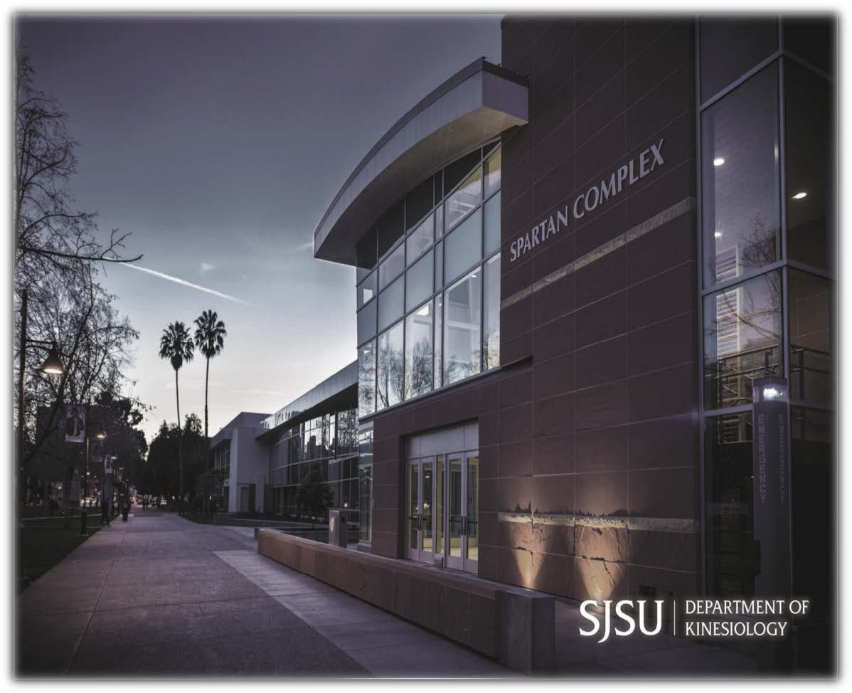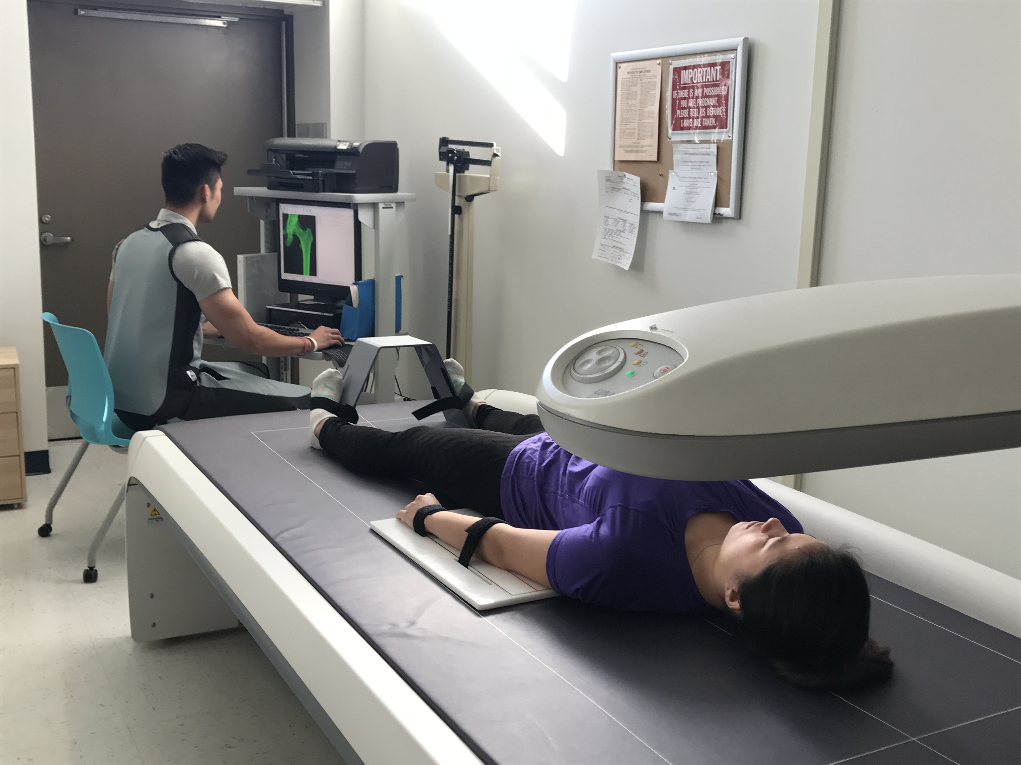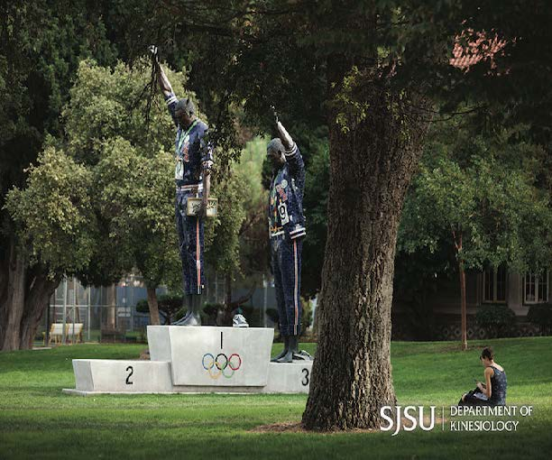

Table of Contents
Greetings and Welcome 3
General Information 3
Entering into a Graduate Program
University Guidelines 5
Department of Kinesiology Guidelines 5-7
Planning your Graduate Studies
Selecting a Academic Advisor 8
Selecting a program 8
Selecting a plan 8
Which plan is right for you? 9-10
Admission to Candidacy 11
Plan A: Thesis
Selecting a thesis advisor and committee members 12
Proposal Meeting
Institutional Review Board approval
Thesis Defense
Graduate Studies and Research Review
Plan B: Project 15
Guidelines
Awards/Grants/Assistantships 17
Kinesiology
Assistantships
Frequently Asked Questions 18

Greetings from the Department of Kinesiology Graduate Faculty

We are pleased to welcome you to the Department of Kinesiology at San Jose State University, and we are excited that you have chosen to pursue your master’s degree in our highly respected graduate program. Our alumni have successfully obtained jobs and entered doctoral programs across the Bay Area, the state of California, the US and abroad, and we hope to count you among them when you complete your studies. You were admitted into the KIN graduate program because of your undergraduate academic achievement and because of your potential to become a successful future professional in a Kinesiology related field. The KIN graduate faculty look forward to working with each and every one of you to insure a meaningful and productive educational experience.
This handbook contains a wealth of information that will help you negotiate the terrain of both the KIN department and the university; it should be your first stop when seeking an answer to program questions you may have. So, please take the time to carefully read through the handbook and become familiar with the policies and procedures included here.
Once again, congratulations on your admission to the SJSU Department of Kinesiology Graduate Program, and best wishes in your journey towards your master’s degree. If there is anything you need, please do not hesitate to ask the front office, the graduate coordinator (Dr. Ted Butryn), or your curriculum advisor. Good luck!

Dr. Ted M. Butryn, Ph.D.
Graduate Program Coordinator

General Information IIInformationInformationeneral Information

San Jose State University

With an enrollment exceeding 34,000 students, including over 3,000 Graduate students, San Jose State University is the oldest campus in the California State University (CSU) system. The 134-acre campus is located in the Santa Clara Valley, the heart of Silicon Valley. For SJSU students, the Silicon Valley location offers an exceptional learning environment. Silicon Valley exists at a cultural crossroads with talented and imaginative colleagues, a place to hone professional skills, and the intellectual vitality of the Bay area.
One of the more prominent and useful features of the SJSU campus is the Martin Luther King, Jr. Library. The library, a unique $177.5 million joint SJSU-City of San Jose project, opened in the Fall of 2004, offers impressive resources for students and community members. New KIN graduates students are encouraged to visit the library as soon as possible upon arriving to campus, and sign up for their library cards. This will enable students to gain access to library materials, as well as materials from other libraries via interlibrary loan and Link-Plus, a program that allows students and faculty to acquire a variety of materials from many libraries within California. https://library.sjsu.edu/

Graduate study at San Jose State University is designed to serve the professional and personal needs of individuals who seek advanced work in many fields. Overseeing all graduate programs is a newly formed College of Graduate Studies (https://www.sjsu.edu/cgs/), which was launched in 2019. The newly revamped Graduate Studies website will be a valuable resource for all current and incoming students in the Department of Kinesiology, and it includes crucial information related to funding opportunities, steps to graduation, and forms. This site, along with the Graduate Admissions and Program Evaluations (aka GAPE) website (https://www.sjsu.edu/gape/) should be your first stops for any general questions you may have about your SJSU graduate student journey.

College of Health and Human Sciences

The College of Health and Human Sciences (CHHS) currently consists of a diverse group of departments, schools, and programs including: Kinesiology, Aerospace Studies, Audiology, Hospitality, Tourism and Event Management, Nutrition, Food Science & Packaging, Occupational Therapy, Public Health and Recreation, Valley Foundation School of Nursing, and Social Work. Outside of an increasing emphasis on public health issues, one common characteristic of the programs in CHHS is the provision of broad based experiences in and out of the classroom to prepare students for careers in government, industrial and educational institutions, reporting, health, and entrepreneurial endeavors.

The Department of Kinesiology

The Department of Kinesiology, housed in the fully renovated Spartan Complex and Uchida Hall, is one of the largest departments in the university and its graduate program has achieved national and international recognition. The graduate program currently has approximately 75 students from across the United States, as well as Canada, Japan, Israel, and other countries. Students can currently choose from four concentrations:
- Sport Management
- Exercise Physiology
- Sport Studies (Including Sport Psychology)
- Kinesiology (General)

The mission of the department is to serve the needs of a diverse society by fostering an understanding and appreciation of, and commitment to, human movement as it contributes to the quality of living and development of the whole person throughout life.
In an atmosphere of social justice, equity, and sensitivity to issues of diversity, the Department of Kinesiology seeks to:
- assist in fulfilling the mission of San Jose State University;
- prepare exemplary Kinesiology professionals;
- promote and provide for lifetime fitness activities for all; and
- promote and provide for the academic study of sport, physical activity, and human movement.

Additionally, the department will:
- provide a high quality educational experience for our students;
- instill respect for learning and the learning process;
- help students learn to learn, think critically and independently;

- prepare students for life and society;
- offer a diverse and contemporary selection of activity, general education, undergraduate, and graduate courses;
- promote and provide for scholarship and professional activity; and
- facilitate and promote community interaction.

Entering the Graduate Program

University Guidelines

Those seeking admission to San Jose State University as a graduate student may apply for a degree or a credential, or a certificate. All applications, regardless of objective, will be reviewed using the following general admissions requirements.

General Admissions Requirements for SJSU. A student shall:
- have completed a 4 year college course of study and hold an acceptable baccalaureate degree from an accredited institution, or shall have completed equivalent academic preparation as determined by appropriate campus authorities;
- be in good academic standing at the last college or university attended;
- have attained a grade point average of at least 2.5 (A=4.0) for general admission to the university (KIN requires a 3.0 to enter as classified) in the last 60 semester (90 quarter) units attempted; and
- satisfactorily meet other standards for graduate study, including qualifying examinations, as appropriate campus authorities may prescribe (depending on program of study).

Department of Kinesiology Guidelines

Upon admission to the graduate program, and prior to registration for coursework, each student should contact their assigned academic advisor. In the acceptance message, the graduate coordinator assigns each accepted student an initial advisor to work with them to construct a program of study. Students are admitted in one of two categories: Classified or Conditionally Classified.

Requirements for admission as Classified. In addition to meeting the university’s general requirements, the Kinesiology Department is looking for the following:
- A baccalaureate degree with a major or minor in Kinesiology (or successful completion of deficiency coursework as assigned by the Graduate Coordinator or an assigned Academic Advisor).
- A minimum grade point average of 3.0 in the last 60 semester (90 quarter units) of work.
- That the student has no undergraduate course deficiencies.

Requirements for Admission as Conditionally Classified. Students must meet the university’s general requirements. The Kinesiology graduate coordinator may approve admission in this category and prescribes undergraduate coursework or other conditions to remedy any deficiencies.
Students with a GPA between 2.75 and 2.99 will be admitted to the program with the requirement that they attain a B (3.0) or better on each of their first two graduate courses.

Students without a baccalaureate degree major or minor in Kinesiology are required to complete a maximum of 12 units (4 courses) of upper division foundation coursework. This coursework does not count towards the 30-unit MA degree.

  - Upper Division Foundation Coursework. The form entitled “Change of Classification” is to be completed by the student’s curriculum advisor (or the department chair during the summer) and graduate student as soon as the foundation requirements laid out by the graduate coordinator are completed. This form is on the GAPE website.

Prerequisites for any foundation course may be reviewed and could be waived, on an individual basis, by the specific instructor of the class. All foundation courses must be at least upper-division undergraduate level (i.e., no JC courses count), and they may be taken either upon admission to SJSU or at another college or university prior to enrolling. Regardless, the foundation courses must be agreed upon by the student and either their advisor, preferably, or in the absence of an initial advisor, the graduate coordinator. Also, SJSU policy states that no more than 12 units of Graduate Coursework may be counted towards the degree while a student is conditionally classified. Therefore, it is in students’ best interest to take at least one foundation course their first semester, and complete the foundation coursework in a timely manner.
The change of classification form is to be signed by the student, academic advisor, and Graduate Coordinator. The completed form will then be handed in to the Administrative Support Coordinator (currently Winston Kwong) and sent to GAPE, after which the student’s status will be changed to classified. This change of status is important, because students must obtain classified status before being admitted to candidacy. (see next section-Planning your Graduate Studies-for more information).
When the change of Classification form is signed by all parties, it should be considered a binding contract. If, for whatever reason, the student wishes to change the coursework outlined on the form, he or she must contact the Graduate Coordinator (or KIN department chair, if the chair signed the original form) and their curriculum advisor. If both parties agree to the change, only then may the coursework outlined on the Change of Classification form be changed. All appeals of assigned foundation coursework will be brought forth to the graduate coordinator for final decision.

Grading in KIN Graduate Coursework. The following points should be carefully considered throughout your graduate degree journey:

- Students may not count a grade of C- or lower towards graduation, and such a grade cannot be included on the student’s final candidacy form. Students receiving a grade of C- of lower in a course must take another course to substitute on the final candidacy form.
- Students must maintain an overall GPA of 3.0 at all times. Failure to do so will result in the student being placed on academic probation, at which time the student will be required to raise his or her GPA above the 3.0 minimum the following semester or risk disqualification from the program. In other words, if a student has a GPA of below a 3.0, and the next semester has a GPA below 3.0, they will be disqualified.
- If a student completes all graded coursework with a GPA of under 3.0, the faculty advisor and student must take additional coursework in consultation with the graduate coordinator and GAPE.
- Students must obtain a B or better in either KIN 250 or KIN 251 to meet the University Writing Competency requirement. Failure to do so requires that the student retake one of these courses and subsequently achieve the B or better standard.

Planning Your Graduate Studies

Selecting an Academic Advisor
Prior to enrollment for any coursework, students should arrange to meet with their academic advisor, who is assigned to each student by the graduate coordinator at the time of acceptance. In addition, students should plan to attend the mandatory KIN student orientation generally held immediately prior to the first full week of classes. The academic advisor is the faculty member that students will consult with throughout their studies regarding selection of coursework and progression towards the Master of Arts degree. While it is recommended that the academic advisor be the person who will eventually be the thesis or project advisor, it is not required. A proposed set of courses should be developed as early as possible in consultation with the academic advisor. The proposed program, as outlined on the Candidacy Form, will eventually be submitted for approval to Graduate Admissions and Program Evaluation (GAPE). Upon approval at all levels, the student will be considered a candidate for the Master of Arts degree.

Selecting a Program
Students may currently choose from one of four concentrations. It is essential that students select a program early to facilitate efficient planning with the academic advisor. Each program requires completion of two core courses (KIN 250, and KIN 251), a total of 30 units, and written competency demonstrated by successful completion (B or above) of KIN 250 or KIN 251. A maximum of 9 units of SJSU credit may be taken outside of the department.

Selecting a Plan
There are two basic plans for completing your master’s degree, and the biggest distinction between the two plans involves what is called the “culminating experience,” or the final intensive endeavor that students must successfully defend before they are eligible for graduation. Plan A involves the completion of a 6-unit Thesis, and Plan B involves the completion of a 3-unit Project. Because the Thesis option is 6-units and the Project option is 3-units, students selecting Plan B will be required to take an additional 3-units of coursework so that they obtain the required 30 units.

Plan A Thesis
Course requirements for all areas of study for the Plan A Thesis option include:
- KIN 250 Fundamentals of Quantitative Research Methods in KIN 3 units
- KIN 251 Fundamentals of Qualitative Research Methods in KIN 3 units
- KIN 299 Master’s Thesis/Project 6 units
- Electives* (Selected in consultation 18 units with the academic advisor)

*Electives are selected based on the student’s area of study. Electives in all plans can include a maximum of 9 units that may be taken at the undergraduate upper division level. In addition, a maximum of 9 units may be taken outside of the Kinesiology Department.

In general, Plan A is a thesis program designed to provide opportunities for in-depth investigation in the student’s area of emphasis. The thesis may employ any methodology that is appropriate for the research question, and approved by the chair of the committee. In the past, students have used a wide range of quantitative, qualitative, and mixed methods designs in their theses. The culmination of the thesis is an oral defense according to university and departmental guidelines. The individual graduate student and academic advisor, with approval by the Graduate Coordinator, determine the thesis requirements and timelines. A signed KIN 299 departmental form is required before a student can register for KIN 299 thesis units, and the form serves as a contract regarding the individual student’s thesis requirements and timelines.

Plan B: Project
Course requirements for all areas of study for Plan B include:
- KIN 250 Fundamentals of Quantitative Research Methods in KIN 3 units
- KIN 251 Fundamentals of Qualitative Research Methods in KIN 3 units
- KIN 298 Special Studies 3 units
- Electives* (Selected in consultation 21 units with the academic advisor)

*Electives are selected based on the student’s area of study. Electives in all plans can include a maximum of 9 units that may be taken at the undergraduate upper division level. In addition, a maximum of 9 units may be taken outside of the Kinesiology Department.

The Plan B option (KIN 298) is a three-unit project that is conducted with the rigor appropriate for graduate work, where the culminating experience is a poster presentation evaluated by a KIN 298 faculty panel. The panel is comprised of all faculty advisors who have KIN 298 students enrolled for that particular semester. The range of KIN 298 projects could include (but not limited to): a research-based web site; research-based business plans; facility feasibility studies; children’s stories/books; product development; educational materials; mental training programs; fitness programs (pediatric—geriatric); historical analysis; educational intervention techniques; psychometric analysis; among others deemed appropriate by the academic advisor. Although an in-depth (minimum 15-pages) literature review is mandatory the final 298 project, a literature review alone does not constitute an appropriate KIN 298 Project.
Individual projects are agreed to by the graduate student and KIN 298 academic advisor, with approval of the Graduate Coordinator, as indicated on the KIN 298 form/contract. The signed Plan B-KIN 298 form/contract will be placed in student’s permanent departmental file. Graduate students must complete at least 21 units prior to their KIN 298 enrollment, including either KIN 250 or KIN 251. Students must work closely with their Plan B advisors throughout this process.

What to consider when selecting the Plan A Thesis or Plan B Project option?
The question of whether a student should complete a thesis or project as the culminating experience of their KIN master’s experience is an important one! There is no correct answer, but the choice to do a thesis or project may depend on many factors, including the type of student, and what goals a student has. In general, the following are some reasons to take on both options, as well as some factors that might dissuade a student from choosing a particular option. In general, students should choose the option that best suits their particular interests and goals in their larger journey towards their degree.

 | Plan A Thesis | Plan B Project
Reasons for pursuing | - The thesis option gives students an opportunity to conduct an in- depth research study, and to directly contribute to the base of knowledge in the field.  - The thesis may yield a conference presentation and/or a journal publication.  - The thesis option is a solid base for the future completion of the doctoral dissertation. | - The project option is generally more flexible, in terms of the types of topics and methods that would be acceptable.  - The project allows students to focus on a particular topic of interest within Kinesiology.  - The project option may have direct applicability to students’ career choice (e.g., manual, website, business plan) or publication.
Reasons to consider other option | - The thesis, with a 6-unit requirement, generally takes longer than the Plan B project.  - The thesis requires students to find faculty members to serve on the thesis committee, or faculty available within the student’s desired timeline.  - The thesis generally requires a high proficiency in research methodology and writing; students with weaker skills in these areas may have a difficult time meeting the committee’s demands. | - The project requires students to find a faculty member interested to spend time necessary due to other obligations (e.g., serving on other thesis committees, professional committees).  - Because IRB (Human Subjects is NOT required if the student does not intend on publishing or presenting the results, interesting findings will never actually get disseminated.  - Students who plan on pursuing a doctoral degree may be at a disadvantage when applying to quality  Ph.D. programs if Plan B is not a research study.

Admission to Candidacy (Note: For candidacy form, see www.sjsu.edu/GAPE

One of the most important steps that graduate students make is obtaining admission to candidacy. The form, commonly known as the “Candidacy Form,” contains demographic information, as well as all of the classes the student is using towards his or her graduate degree. Foundation coursework cannot be used on the graduate student’s candidacy form. The candidacy form must be completed approximately a semester and a half prior to anticipated graduation, although it is recommended that students turn in their candidacy forms as early as possible after they have completed at least 12 units towards their 30-unit masters program.
Students should consult regularly with their curriculum advisor to ensure that they are on the correct path towards graduation, and that the admission to candidacy form is submitted in a timely manner. The admission to candidacy process includes the following:

University Requirements. Students who have matriculated (been admitted to the university and enrolled in classes) and received Classified standing in a Master’s degree curriculum must next be admitted to candidacy for the degree. The following qualifications and procedures are necessary:
  - At the time the student applies for admission to candidacy for the Master’s degree, the grade point average for all courses taken at SJSU as a graduate student must be at least 3.0. In addition, the GPA for all courses taken which are to be included as part of the 30-unit program for the Master’s degree must be at least 3.0. A student is not admitted to candidacy until the nine units of graded work (100 or 200 level course acceptable to the college and department in which the degree is sought) are completed as a graduate student at SJSU.

Submitting proposed program. After satisfactory completion of any required examinations and attainment of the scholarship criteria noted above, the graduate student, in consultation with the academic advisor, initiates an official Department request for approval of candidacy form (available in the KIN main office; see Appendix G). The candidacy form, which serves as the student’s formal request, must list all courses and other requirements that the student must fulfill to receive the degree. The proposed program must:
  - contain exactly 30 units.. KIN requires that at 15 units must be from 200 level courses and minimum of 60 percent must be letter-graded coursework.
  - be chosen from within the offerings of the major department, or it may include combinations of offerings drawn from other fields acceptable to the major advisor.
  - have at least 80% of the coursework listed for the degree completed in residence (i.e. a maximum of six units may be transferred in from other institutions).
  - not contain any basic skills courses, foundation coursework, student teaching, 300 level residence, 400 level extension courses taken at SJSU or extension/correspondence courses taken at other institutions, or any credit by examination courses.
  - contain no more than six semester units of credit for the thesis units (KIN 299)
  - contain no more than three semester units of credit for KIN 298 if Plan B.

* The proposed program must then be approved by the departmental Graduate Coordinator and then GAPE.

Plan A: Thesis Guidelines

Selecting a Thesis Advisor and Committee Members

Any tenured or tenure-track faculty from the Department of Kinesiology may serve as the chair of a thesis committee. The selection is the responsibility of the student. Students should select this thesis advisor prior to the time they intend to initiate any work towards the thesis. To facilitate smooth and efficient progress toward completion of a thesis, students should work closely with this faculty member throughout the process.
A thesis (Plan A) committee shall be composed of no fewer than three voting members who must have at least a Masters Degree or equivalent. Any qualified individual – including part time temporary faculty, faculty on partial retirement, or others with expertise related to the thesis topic – may serve as a committee member, however, the majority of the committee members must be tenured or tenure track SJSU faculty members. In addition, persons with expertise useful to designing and completing the project may serve as consultant to the committee and/or student. Current students may not serve as voting members of the committee. Committee members should be selected in consultation with the thesis advisor and serve as relevant sources of input and advice.
The thesis will be worth a total of six units. How the units are scheduled into a student’s program is a decision made between the thesis advisor and the student. The following is an example of a generally accepted breakdown of KIN 299 units, although often students may register for all 6 units, receive a grade of RC (Report Credit) and finish the thesis the following semester:

  - 3 units – Choose topic, choose advisor, write chapters 1, 2 and 3; Proposal meeting
  - 3 units-Human Subjects Institutional Review Board (IRB) approval, collect and analyze data, write chapters 4 and 5; Oral defense

The graduate student must complete the oral proposal to obtain the third thesis credit. The student must complete the oral defense to obtain the sixth thesis credit.

Thesis Formats: Standard or Manuscript
Students have the choice of completing their Master’s theses in one of two formats. The standard format is chosen by the majority of KIN students, and it involves the completion of a five chapter document consisting of the following: 1) Introduction, 2) Literature Review, 3) Methodology, 4) Results, and 5) Discussion and Conclusions. In some cases, it may be appropriate to include “Recommendations: in the title of chapter 5. The manuscript format takes the form of a journal article written in the format of the journal being targeted for submission. Thus, the sections of the manuscript format thesis are: 1) Introduction, 2) Journal Article, and 3) Full support materials (i.e. Entire contents of Chapters 1, 2, and 3). Students may check out previous Master’s theses from the main office (SPX 56) for review. Students will receive information on the Standard Thesis Format in the KIN 250 Research Methods course, and the guidelines for the Manuscript Format may be found on the departmental website, as well as on the Graduate Studies website.
*NOTE: The SJSU thesis guidelines may be revised periodically, so students must consult the SJSU GAPE and Graduate College website for the most current formatting information.

Proposal Meeting
Following approval of a topic by the thesis advisor, students should prepare a first draft of the introduction, review of literature and methods sections of their thesis proposal. Upon approval of this work by the thesis advisor [likely to occur only after revision(s)], other committee members should be asked to review the work. After feedback is obtained, a proposal meeting should be planned. Graduate students should allow at least 10 days for committee members’ review of their thesis proposal before scheduling the proposal defense meeting.
Students are responsible for making all meeting arrangements, including the reservation of a meeting room. At that time, students formally propose their research and committee members provide specific direction for future work if the proposal is accepted. Once accepted by the thesis committee, students may then submit their work to the Graduate Studies and Research office for approval by the Human Subjects Institutional Review Board (HS-IRB).

The presentation requirements/guidelines for the thesis proposal and defense meetings are as follows:
  - Students submit proposal to committee members at least 10 days in advance for oral proposal or defense; Faculty have the right to request additional time if the 10-day period is not adhered to;
  - Twenty minute maximum presentation time limit by the student;
  - Forty to sixty minute question and answer time limit;
  - Student and all guests leave room for faculty evaluation of presentation/paper;
  - Pass/Pass with Modification/Fail determined by committee. (Secret ballot may be requested at the Committee Chair’s discretion).

Human Subjects Institutional Review Board (HS-IRB)

Federal and California State statutes as well as University policy require investigators conducting research involving human subjects to be knowledgeable about and to comply with regulations for the protection of human subjects in research. The Institutional Review Board exists to insure that the rights of participating subjects are protected and to provide the oversight necessary to assure that all policies regarding the use of human subjects are adhered to.
Instructions and forms which need to be completed are available on-line: https://www.sjsu.edu/research/research-compliance/irb/index.php

All investigators conducting any research using human subjects must, in accordance with SJSU policy:
  - Obtain HS-IRB approval prior to soliciting subjects or collecting data. This includes projects that require HS-IRB approval and/or approval of requests for exemption from review (including pilot studies).
  - Provide potential subjects with information necessary to make an informed decision regarding participation in the study.
  - Protect the confidentiality of all subjects participating in research and all data that may be collected from the subjects.
  - Provide special safety procedures, as needed, to avoid any harm to subject

Defense of Thesis
When the research is completed and in final written form students formally present their work to their thesis committee for approval. The focus of the presentation at this point is on the results observed and the conclusions drawn. The thesis is then (a) accepted, (b) accepted with required revisions, or (c) rejected. If revisions are required they must be completed and approved by the committee before the thesis can be submitted to the Graduate Studies and Research Office.
Due to established University deadlines for graduation, students must establish, in consultation with their thesis advisor, reasonable timelines for completion of the thesis. These timelines must take into consideration the time committee members need to review and comment on written work, the time needed for the HS-IRB to conduct its review, and the time students need to revise and rewrite large and small portions of the thesis following critiques from the thesis advisor and committee members. Students and their advisors should regularly consult and make note of deadlines for submitting completes theses for review to Graduate Studies. Students must consult Graduate Studies website for deadlines.

Plan B Project Guidelines

Graduate Program Approval

Students wishing to complete the Plan B Master’s Degree program should confer with their academic advisor and file a program to obtain approval by the departmental Graduate Coordinator. The approved program must be on file before submitting an application for the KIN 298 project. The KIN 298 form in on the KIN website in the “forms” section. When the Grad Coordinator signs the form, the current administrative coordinator (Winston Kwong) will send the student an add code to register for their 298 units within approximately a week.

Selecting a Plan B (KIN 298) Advisor

Any tenured or tenure-track faculty member from the Kinesiology Department on duty during the full academic year may serve as the advisor of a KIN 298 project. The selection is the responsibility of the student. Students should select this advisor prior to the time they intend to initiate any work towards the KIN 298 project.

KIN 298 Projects

KIN 298 is the three-unit project with rigor consistent with graduate work (not less than 100 hours), where the culminating experience is a poster presentation. The following are the general presentation guidelines for the KIN 298 poster presentation (see also Plan B Poster Presentation link/download on the Department of Kinesiology website). NOTE: Students should consult directly with their Plan B advisor for specific information on how to develop and appropriate and rigorous Plan B project.
After the final day of adds for each semester, the Graduate Coordinator creates a Canvas page for the KIN 298 students, and all students and advisors are invited to the page. All deadlines and requirements of the 298 projects are available on this Canvas page, as are examples of previous Plan B posters. Again, it is the student’s responsibility to work closely, and regularly, with their Plan B advisor to develop their project.

- Graduate students must complete at least 21 units, AND have taken either KIN 250 or 251 prior to their KIN 298 enrollment.

Panel Evaluation of KIN 298 Projects

The KIN 298 project is intended to be a culminating experience for Plan B graduate students. The students formally present their project work in the form of a poster presentation to a KIN 298 panel for its approval. Based on the filed abstract and presentation by the student, the KIN 298 project is evaluated by the panel as: (a) pass or (b) fail (must return next semester and re-register for 3 units of 298). NOTE: If a student, in consultation with their advisor, have completed work on their 298 project, but for whatever reason determine ahead of time that they cannot finish, a grade of RP (Report Credit) may be assigned. This means that the students will receive a code the subsequent semester for a 1290R enrollment, the cost of which is significantly less than re-enrolling for the full 3-units of KIN 298. So, students should carefully consider the potential outcomes in moving forward with a subpar 298 project.
Policy Addendum (Passed in Fall 2016): Beginning 2017 Spring semester, all completed Plan B materials (APA abstract, literature review, deliverable product, and poster) must be submitted to the student's advisor for review and approval not less than 7 days before the Plan B poster presentation date, unless permission has been granted by the student's advisor, or the student will receive a no credit (NC) grade.

IRB Policy for KIN 298: Currently, if the student and advisor have NO intention to publish or otherwise present ANY aspect of the project results outside of SJSU, they will complete the SJSU IRB Exclusion Worksheet (See IRB website). If a student has the intention (or sees a possibility) of presenting or publishing their work, they must go through the full IRB approval process, as detailed on the IRB website. Please work with your advisor to determine the proper route for your project.

Awards/Grants/Assistantships

Kinesiology Department Scholarships: Applications are located on KIN website in “Scholarships” section. For more information, please contact Dr. Armstrong (KIN Associate Chair) who manages the KIN funding opportunities.

Kinesiology Assistantships
Teaching Associate (TA) positions are available for graduate students pending availability of funds and courses. Students who are interested in applying for one of the positions fill out the GA/TA forms located on the KIN website in the “forms” section, and submit directly when applying via Cal State Apply, AND send directly to the graduate coordinator (currently Dr. Ted Butryn). Students who obtain TA positions usually teach activity classes and/or laboratory sections of undergraduate theory courses. They are usually assigned between one and three activity classes or laboratory sections each semester, with a limit of four semesters. To qualify as a Teaching Associate, students must (a) be enrolled in classified standing, (b) maintain a GPA of at least 3.00, and (c) be enrolled in at least three units of coursework each semester. Decisions on TA assignments are made by the Graduate Coordinator and the Activity Coordinator, and the Activity Coordinator will oversee the evaluation of TA performances.

Frequently Asked Questions (FAQ)

- How do I enroll in the Department of Kinesiology Graduate Program?
  - You enroll through the Cal State Apply website, where you upload all documents.
2. Do I need to take the GRE?
  - NO: Due to the lack of predictive value for our graduate program, the GRE is not required at this point.
- Do I need to submit letters of recommendation to KIN?
  - Yes, two letters of recommendation are needed at this time. They are to be submitted directly during the Cal State Apply process, or electronically with a verified e- signature to the current graduate KIN coordinator.
- What if my overall GPA falls below 3.0?
  - See the graduate studies website for a complete explanation of options. In general, however, if your GPA falls under a 3.0 (overall, as well as for the coursework to be counted towards your 30-unit MA degree) you are placed on probation. You must raise your GPA immediately the next semester, or risk disqualification from the university.
- Do I have to declare a concentration?
  - Early on in the program, if not at the time of applying, students should certainly decide upon a concentration, and choose an academic advisor who is most closely aligned with their main area of interest. The strength of the KIN program at SJSU is its flexibility, and thus students and the faculty advisor have the ability to construct a program that meets the specific needs of the student.
- How do I get a teaching assistant position?
  - Please contact the Graduate Coordinator, as well as the KIN Department Chair for consideration for one of our open graduate assistant positions, and fill out the required GA/TA forms on the KIN website. These positions are contingent on activity class openings and available budget.
- How long do I have to graduate?
  - As outlined on the SJSU grad studies website: “All work on your graduate degree program must be completed within seven years preceding the award of your degree. If courses become outdated a student has the following options:
    - Submit a course substitution form to replace the outdated course.
    - Repeat the outdated course without credit.
    - Revalidate the outdated coursework by examination. This petition must be initiated by your graduate advisor.
- How many graduate students are in the department of Kinesiology?
  - This is a good question! At any given time, there are approximately 70-80+ students in the KIN grad program.
- How many classes can I transfer into the department?
  - You may transfer a maximum of six units to your 30-unit MA in Kinesiology. However, any courses to be transferred into KIN are subject to approval by the KIN Graduate Coordinator and faculty advisor. We do not accept any substitutions for our two core courses (KIN 250 & 251).
- How many classes can I take outside of the department?
  - A KIN master’s student may take a maximum of nine (9) SJSU credits outside of the department, although this is contingent of approval from your academic advisor. In addition, no lower-division courses may be counted towards the degree.

- How do I obtain classified status?
  - If you are admitted to KIN as conditional due to a GPA below 3.0, you must provide the Grad Coordinator proof of a grade of B or above in your first two KIN grad courses as soon as they are completed. You will also fill out the “change of classification” form on the Grad Studies or GAPE website. The Coordinator will sign the form, and you will obtain classified status. If you were admitted as conditional due to the need to complete
foundation coursework, you must contact the Grad Coordinator as soon as you have
completed the required units, fill out the change of classification form, and you will then obtain classified status.
- What if I need to take time off from my SJSU studies?
  - If you are in good standing, and have been enrolled for a semester, then you may take a semester off. Please see the SJSU Grad Studies website for more information.
- What do I write in the “Competency for Written English” section of the candidacy form, otherwise known as the Graduate Writing Requirement?
  - You write the semester that you successfully completed either 250 or 251 with a grade of B or above.
  - If, for whatever reason, you fail to achieve a B or above in either 250 or 251, please see the graduate coordinator for a plan by which the GWAR can be met. In general, the ONLY option is retaking either of these courses.

