Integrating Standards Education
into the Business School Curriculum
Part 1 of 2

Final Report – submitted 6/30/2014
Award 60NANB12D285
NIST Measurement Science and Engineering (MSE) Research Grant Programs
Standard Services Group (SSG) Grant Program

Stephen K. Kwan, Ph.D.
Lucas Professor of Service Science
Corresponding author: stephen.kwan@sjsu.edu

Nitin Aggarwal, Ph.D.
Associate Professor,
Management Information Systems

Lucas College and Graduate School of Business
San José State University
One Washington Square
San José, CA 95192

2014

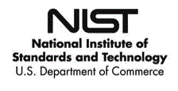

Abstract
Standards are ubiquitous, yet the U.S. workforce awareness about the importance of standards and their economic and societal impact is minimal. For example, very few people will attribute the emergence of global trade and commerce to standardization of shipping containers in 1956. We attribute this lack of awareness to the dearth of standards education in many institutions of higher education in the U.S. In this project we identify reasons attributable to the lack of standards education in universities and outline a solution for generating interesting, relevant and engaging teaching materials to overcome these shortcomings. The developed solution is stealthy and not intrusive, by design, so that it can be easily adopted and integrated with existing teaching materials. We illustrate this solution with examples applicable to an undergraduate business systems and policy course in an accredited business curriculum. We intend to disseminate the teaching materials to the community. We also discuss how this solution could be implemented for graduate level courses in business.

Introduction
Few people, if any, would know and attribute the advancements in global trade, outsourcing, and shrinking of the world distances to standardization of shipping containers. Yet, the fact of the matter is, with standardization of shipping containers in 1956, the cost of shipping was drastically reduced, and the shipping process greatly simplified, making large-scale outsourcing and offshore manufacturing commercially feasible (Levinson 2008). The containers carrying goods were freely and easily transferable from sea to rails to trucks to cities in a highly automated fashion thus permanently changing the economic milieu of the world.
This is just one of the many examples where standards have had a major impact on our way of life. Unfortunately, when milestones like these get ignored while educating masses, it makes it difficult for the workforce to recognize and use such opportunities for economic gains. We believe that there is a significant problem of lack of workforce awareness in standards. As a result, there is limited knowledge among the general population on standards, what they are, how they impact enterprise strategies and decisions, how they affect our purchase decisions and choices, how they affect our lifestyle, etc. We attribute this shortcoming directly to the lack of standards education in many institutions of higher education in the U.S.
We have identified at least three reasons why standards education is missing in higher education curricula. First, there is a lack of awareness that standardization issues are not just technological and engineering in nature but span across many disciplines such as business, sciences, arts, law, and medicine, etc. Second, there is a lack of appropriate and interesting course material, textbooks, case studies, and other study guides that are conducive to teaching and engaging the students. Third, even though coverage of standards-related topics is required by some discipline-specific accreditation agencies (e.g., ABET), the amount, vigor, and even common content and assessment criteria are not clearly specified. As a result, standards education is not a prominent subject area in university curricula. This is particularly true in business school curriculum even though business graduates are as likely to encounter standards-related issues in their career as their engineering peers. This lack of standards education has long-term consequences for the U.S. economy since the knowledge and expertise of the current generation of the workforce with standards acumen are not being sufficiently replenished.
In the next section, we discuss the three problems in detail and provide support of our premise. We then describe our solution to address the problems based on our recommendations. Project personnel and qualifications, institutional capabilities, are included in Appendix B.

Background

Standardization issues
Standardization issues are usually thought of as technical in nature. For example, issues such as how disparate technologies are made to work together? Or how information is exchanged between these systems? One would imagine that the solutions to these technical problems would also be technical. However, this is far from reality. Standardization involves many stakeholders with their own agenda. As a result, the solutions are usually a compromise of everyone’s expectations or in most cases, resulting in a minimum specification that achieves interoperability among systems. This makes standardization as much of a social, economic, and political process as it is a technical issue. Unfortunately dealing with something like this is not something that is intuitive to most people, including experts in their own disciplines. It requires training and education to get a standards perspective and lack of this perspective could result in missed opportunities.

Lack of course material
In this project we focused on standards education in an accredited business curriculum. We are confident that what we developed can be easily extended to other disciplines. We surveyed the top five textbooks for a business systems and policy course and found no reference to standards or standards-related issues. These textbooks are designed for an introductory course that is required of all business students and covers business technology topics like running an enterprise to using technology for competitive advantage.
The lack of coverage in the textbooks means that standards issues do not come up for discussions in the class in any form. As a result, the business students do not get familiarized with the concepts of standards, their impact on our society, and their value addition in our economy.

Lack of direction
Some agencies such as ABET require coverage of standards-related topics as part of a course curriculum in their respective disciplines. However, the content area and assessment criteria for such requirements are usually not explicitly specified and vary widely from discipline to discipline (e.g., in different Engineering curricula such as electrical engineering, industrial and systems engineering, etc.).
Often times the standards are studied and researched in the business school particularly in the areas of Technology Management, Management Information Systems, Innovation, and Competitive Strategy. However, the coverage is limited to few graduate level electives or academic research, but not a part of business school curricula. Standards are also not considered a part of the Business Knowledge in an AACSB accredited curriculum.

Proposed Project
An obvious solution to the problem would be to introduce courses on standards in the appropriate disciplines. However, this is not a viable solution because of the inflexibilities in the structure and operations of universities. There are immense bureaucratic barriers in introducing new courses. The problem is amplified by the lack of understanding of the use and importance of standards by faculty. Another problem is that standards cannot be tied to a single domain. For example, just in the area of information systems, we have database standards, networking standards, programming standards, systems analysis and design standards, service quality standards, etc. As a result it will be difficult to introduce so many standards courses in every area. Thus, we feel that just introducing courses on standards will be impractical and unreasonable.
  - Plan
We believe that, targeting course material supplements without requiring the modification of the course syllabus, while maintaining the accreditation agency’s assessment goals, is much easier to implement and a much more practical approach than introducing a new course. We advocate a non-intrusive method to introduce standards into the curriculum by stealth. To demonstrate, we developed and will share teaching materials for a business curriculum. Our intended point of stealth entry is in the upper division business systems and policy course required for all undergraduate business majors. The course is usually required as the implementation of the undergraduate Program Learning Goals of Business Knowledge, Critical Thinking, and Innovation in an AACSB International accredited curriculum.
To develop a set of useful course materials that can be easily integrated with the existing course curriculum, we surveyed a variety of textbooks to identify a common theme (see Appendix A for more specifics). We also reviewed different versions of the same book to identify trends and contemporary topics. What we found was that almost every book covers traditional topics such as strategic use of information systems, databases, networking, and data communication. These topics had remained the same across many versions of the books. In these chapters we often found short case studies and vignettes scattered throughout the pages to illustrate topics being covered.
While reviewing the textbooks, we also noticed that the most recent versions of the above books were trending towards introducing chapters on newer technologies such as e-commerce, social media, mobile commerce, cloud computing, and globalization. It is these areas that we feel our contribution will be maximized because these topics will become mainstream in the next few years and it will be easier for us to incorporate new terminology along with new concepts.
We wrote a series of short case studies that could be used as supplemental materials to illustrate and strengthen discussion of these topics. These case studies were crafted from real world scenarios taken from enterprise practices and business news that have relevance to standards. We prepared student study and discussion questions as well as teaching notes to accompany each case. The teaching notes identified areas where the instructor could bring in the relevance of standards and enhance the discussion in doing so. We believe that it is possible to produce such case studies for many, but not all, the areas covered in the course. We have made the materials as easy to adopt and integrate as possible regardless of which specific textbook was adopted by an instructor.
Some examples of topics that are trending in the technology policy course that a stealthy insertion of standards could be easily accomplished:
- Mobile Payment Methods for the burgeoning e-commerce industry with mobile devices. This could lead to a discussion of multiple incompatible payment methods being employed in the U.S, and the need for standardization. This might also lead to discussion of international standards.
- The role of standards and standardization in a global economy. This is particularly relevant in the discussion of “The World is Flat”; a topic covered in most of the textbooks (Friedman 2005).
- Cloud computing and its impact on enterprise computing and cross-border provision of online services. Standards and standardization are significant part of the fabric that has technological as well as political and international trade implications.
- The role of standards and patents in competition. For example, the “standards essential” patents acquired by Google from Motorola Mobility are part of an antitrust investigation by the Federal Trade Commission and the European Commission. The issues relates to patents, standards, reasonable and non-discriminatory license fees, global trade, intellectual property violation, etc. (Winkler 2012).
To disseminate these materials we intend to develop a website to provide free access and updates. We will announce and promote the availability of such materials to the Information Systems faculty community via mailing lists such as ISWorld, and other mailing lists from American National Standards Institute Committee on Education (ANSI COE), European Academy for Standardization (EURAS), International Cooperation on Education about Standardization (ICES), etc.
The website will contain general materials about standards education, pointers to other resources (from ANSI, NIST, IEEE, ICES, etc.) and background information about the relevance of standards in the business curriculum. These materials will serve as motivation and resource to potential adopters of the teaching materials.
The utilities of teaching materials depend on their freshness and relevancy. We will encourage faculty members interested in the concept develop their own materials and make them available on the website. The project co-PI’s will act as moderators of the submissions. The materials will be made available under the Creative Commons License. The authors retain copyrights to the materials and will be able to choose specifics of the license.
We will also encourage the submission of feedback updates to the case studies. It is common practice to ask students to provide updates to the scenarios as part of classroom discussion. A sample question would be: “what strategy was adopted by the enterprise and what is the current direction taken by the enterprise?” With such updates, it is possible to sustain the usability of the materials without having to re-write the cases frequently. These updates could be easily incorporated into the website. We will also implement a Web 2.0 platform for an online forum for instructors who adopted the use of the case studies to provide feedback and other user-generated-contents. Thus the community will be able to share and shape their experience in using the teaching materials. The community would also benefit from learning about how some instructor use the materials in some innovative manner.
  - Experimentation and Assessment
We experimented using the case studies with students enrolled in our College of Business’ accredited undergraduate program. They are representative of business students in many universities since they have to take similar courses covering accounting, finance, operations, organizational behavior, strategy, etc. The upper division business systems and policy course (BUS4 188) is one of the required core courses in the curriculum. Our College offers about 500 seats of the course per semester. During the project period we worked with scheduled instructors to employ some of the developed case studies in teaching this course. We conducted an assessment as to how well the students understand the case studies and whether they learned the conveyed concepts of the importance of standards in the business world. See Appendix B for a list of resources available in Institutional Capabilities.
  - Adoptability for Graduate Business Curriculum
The proposed stealthy integration of standards educational materials into an undergraduate business course can be adopted for graduate level courses. Topics related to business technology and policy is usually not covered in a single course in an MBA curriculum. The best target for insertion will be elective courses such as Technology Management, Supply Chain Management, and Business Strategy. MBA students are already familiar with analyzing case studies and there will be little resistance in using the method. On the other hand, the students are used to longer and more detailed case studies (such as those available from the Harvard Business School) and short case studies might be considered too trivial. The adoption of what we developed into more extensive teaching materials with study and analysis questions suitable for a graduate business curriculum will be a logical extension to this project.

Summary
In summary we felt that standards are underappreciated in our society and the lack of appreciation stems from the lack of education and training in standards. We addressed the problem by proposing to strengthen the business curriculum by providing relevant teaching materials on standards that could be easily and stealthily integrated. We intend to develop a web-based distribution of the materials free of charge as well as provide a platform for the community to generate contents, share and shape their experience.
In the next section, we will describe the activities and accomplishments during the project period.
- Project Details
The project was conducted from 10/1/2012 to 9/30/2013. A no-cost extension was approved for the project until 4/30/2014. This Final Report is submitted within sixty days of the project end-date on 6/30/2014.
  - Period 10/1/2012 – 3/31/2013
A first interim report for the project was filed for the period. The interim report described that the project personnel made an invited presentation at the “Workshop on Strategic Standards Management: A neglected Competitive Underpinning” held at UCLA on June 4-5, 2013. The workshop was partly sponsored by NIST. Many of the presentation slides were enhanced and included in the second interim report and are shown in the next sub-section.
The first part of the presentation described the project premise and the challenges of integrating standards education into the business school curriculum. We also delved into our approaches of inserting standards-related topics “by stealth”. We explained how we identified the target undergraduate course: BUS 188 Business Systems and Policy that has up to 500 students enrolled per semester.
We then explained how we investigated the popular textbooks used in BUS 188 that is a staple in the business school curriculum. We further identified topical areas where standards-related topics could be introduced.
We then showed the draft of Case 1 “Software Defined Network – Is it real or is it SDN?” We discussed the background of the case and the motivation of bringing in the concept that in this technology area there are no de facto standards and there are many vendors competing vigorously in the space. It is an interesting technology development since it is very disruptive in the industry. We also brought in an example of an open platform that has many prominent participants (OpenDaylight). Some of the discussion points for the case are:
• Industry Competitive Analysis – Michael Porter
• Disruptive Technology
• Competing Standards/Approaches: ONE, OpenFlow, OpenDayLight
• Openness? Open API’s; How Open is Open?
• Industry Collaborative Projects – “Keep your friends close but your enemies closer”
We also brought in examples how one industry leader reacted to the disruptive technology and that some of the members of OpenDayLight that are working together are competitors.
We then brought in the premise of Case 2 “Electric Car Charging Stations”. In this case there are also no de facto standards and the competition is fierce since electric cars are getting popular in the US. Part of the case will also describe how industry leaders are creating incompatible charging stations are part of their strategy of gaining market share.
We then presented the draft of Case 3 “Wireless payment – Wallet Share”. This is a case that is rich with teaching points since the technology is new and the students would resonate with the premise of using technology to pay for goods and services. We have also prepared some preliminary discussion points for the case.
Finally we described some additional cases that we will be pursuing for the project.
  - Period 4/1/2013 – 9/30/2014
A second Interim Report for the project was submitted for this period. The project efforts for this period were summarized in an invited presentation at the NIST-sponsored “Workshop for 2012-13 Grant Recipients” held at NIST on November 8th, 2013. This report represents significant progress made since the report for the period of 10/1/2012 to 3/31/2013.
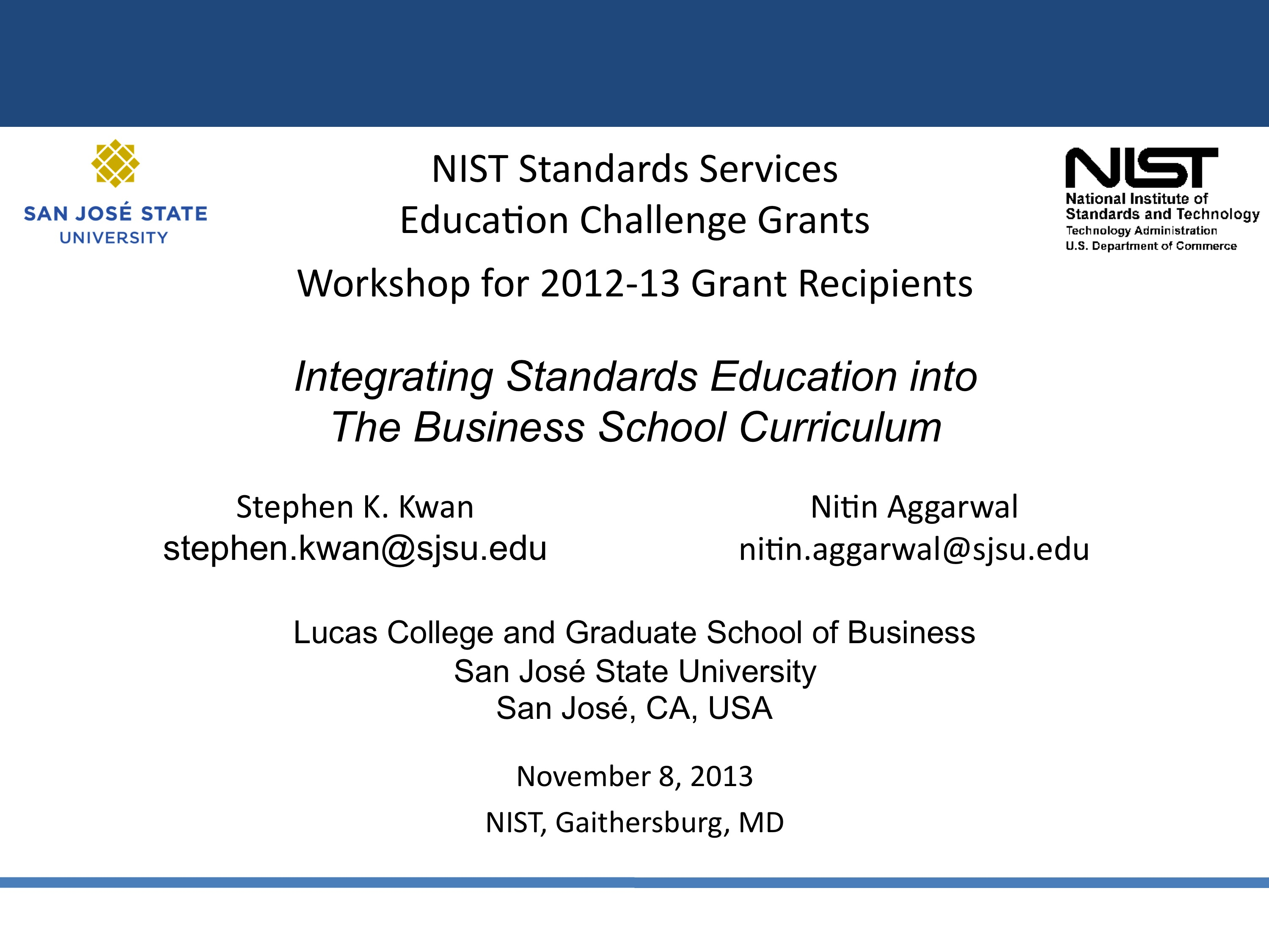
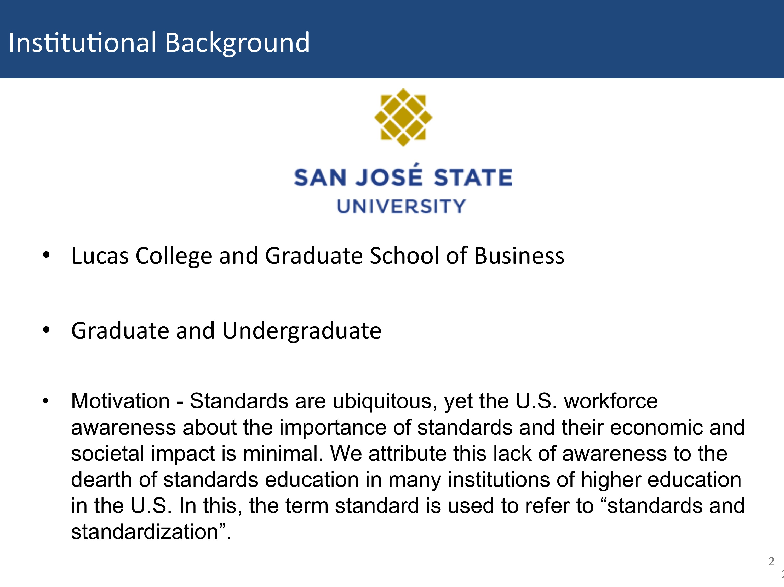
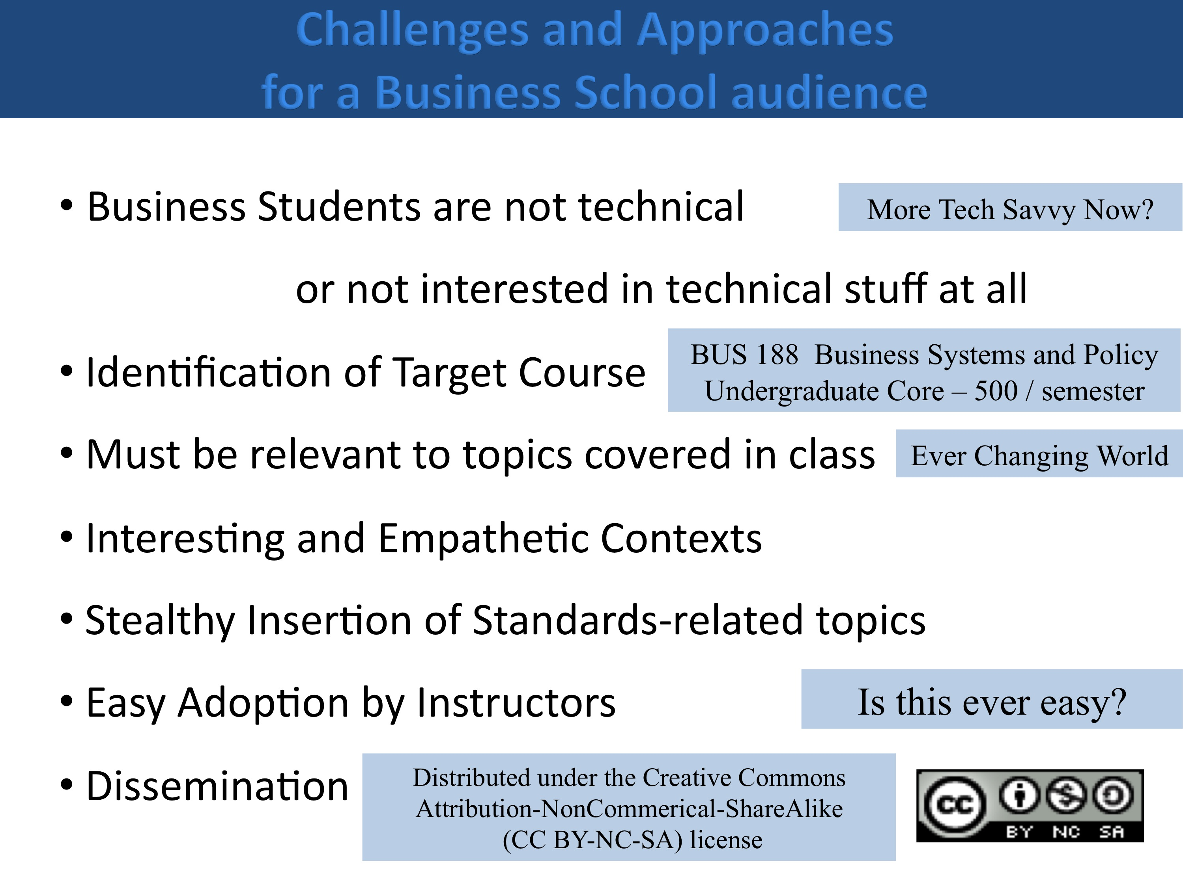
We have gained some experience in teaching the cases to business students (described later in the report) and found that even though they are not technically oriented (as compared to, say, engineering students), they are tech savvy (probably due to pervasive use of personal technology). Most of the topics we picked as potential for writing cases are still relevant and updates are needed since the technology world is constantly in motion. We were fortunate in getting help from two faculty colleagues in trying out one of the cases in their classes, we have concerns that it might not be easy to convince faculty from other institutions in adoptig the cases. To facilitate dissemination, we have decided to distribute the cases in the future under a very liberal no-cost Creative Commons license.
We were on tract in meeting the project’s Core Objectives as shown below.
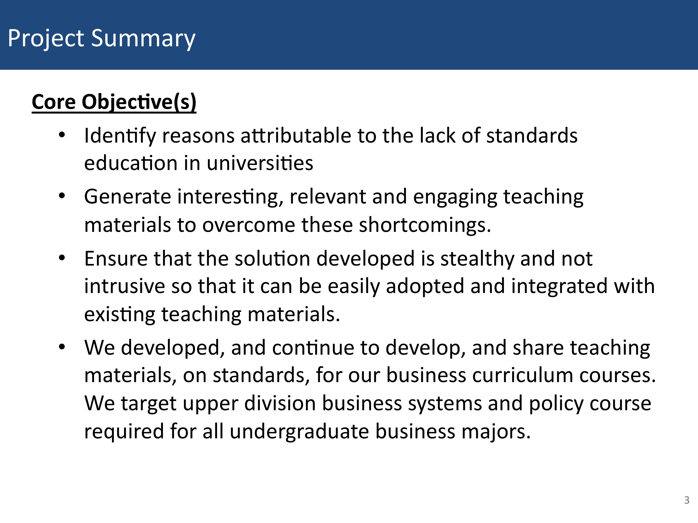
The textbook being used in the target BUS 188 class is “Using MIS” by David Kroenke.
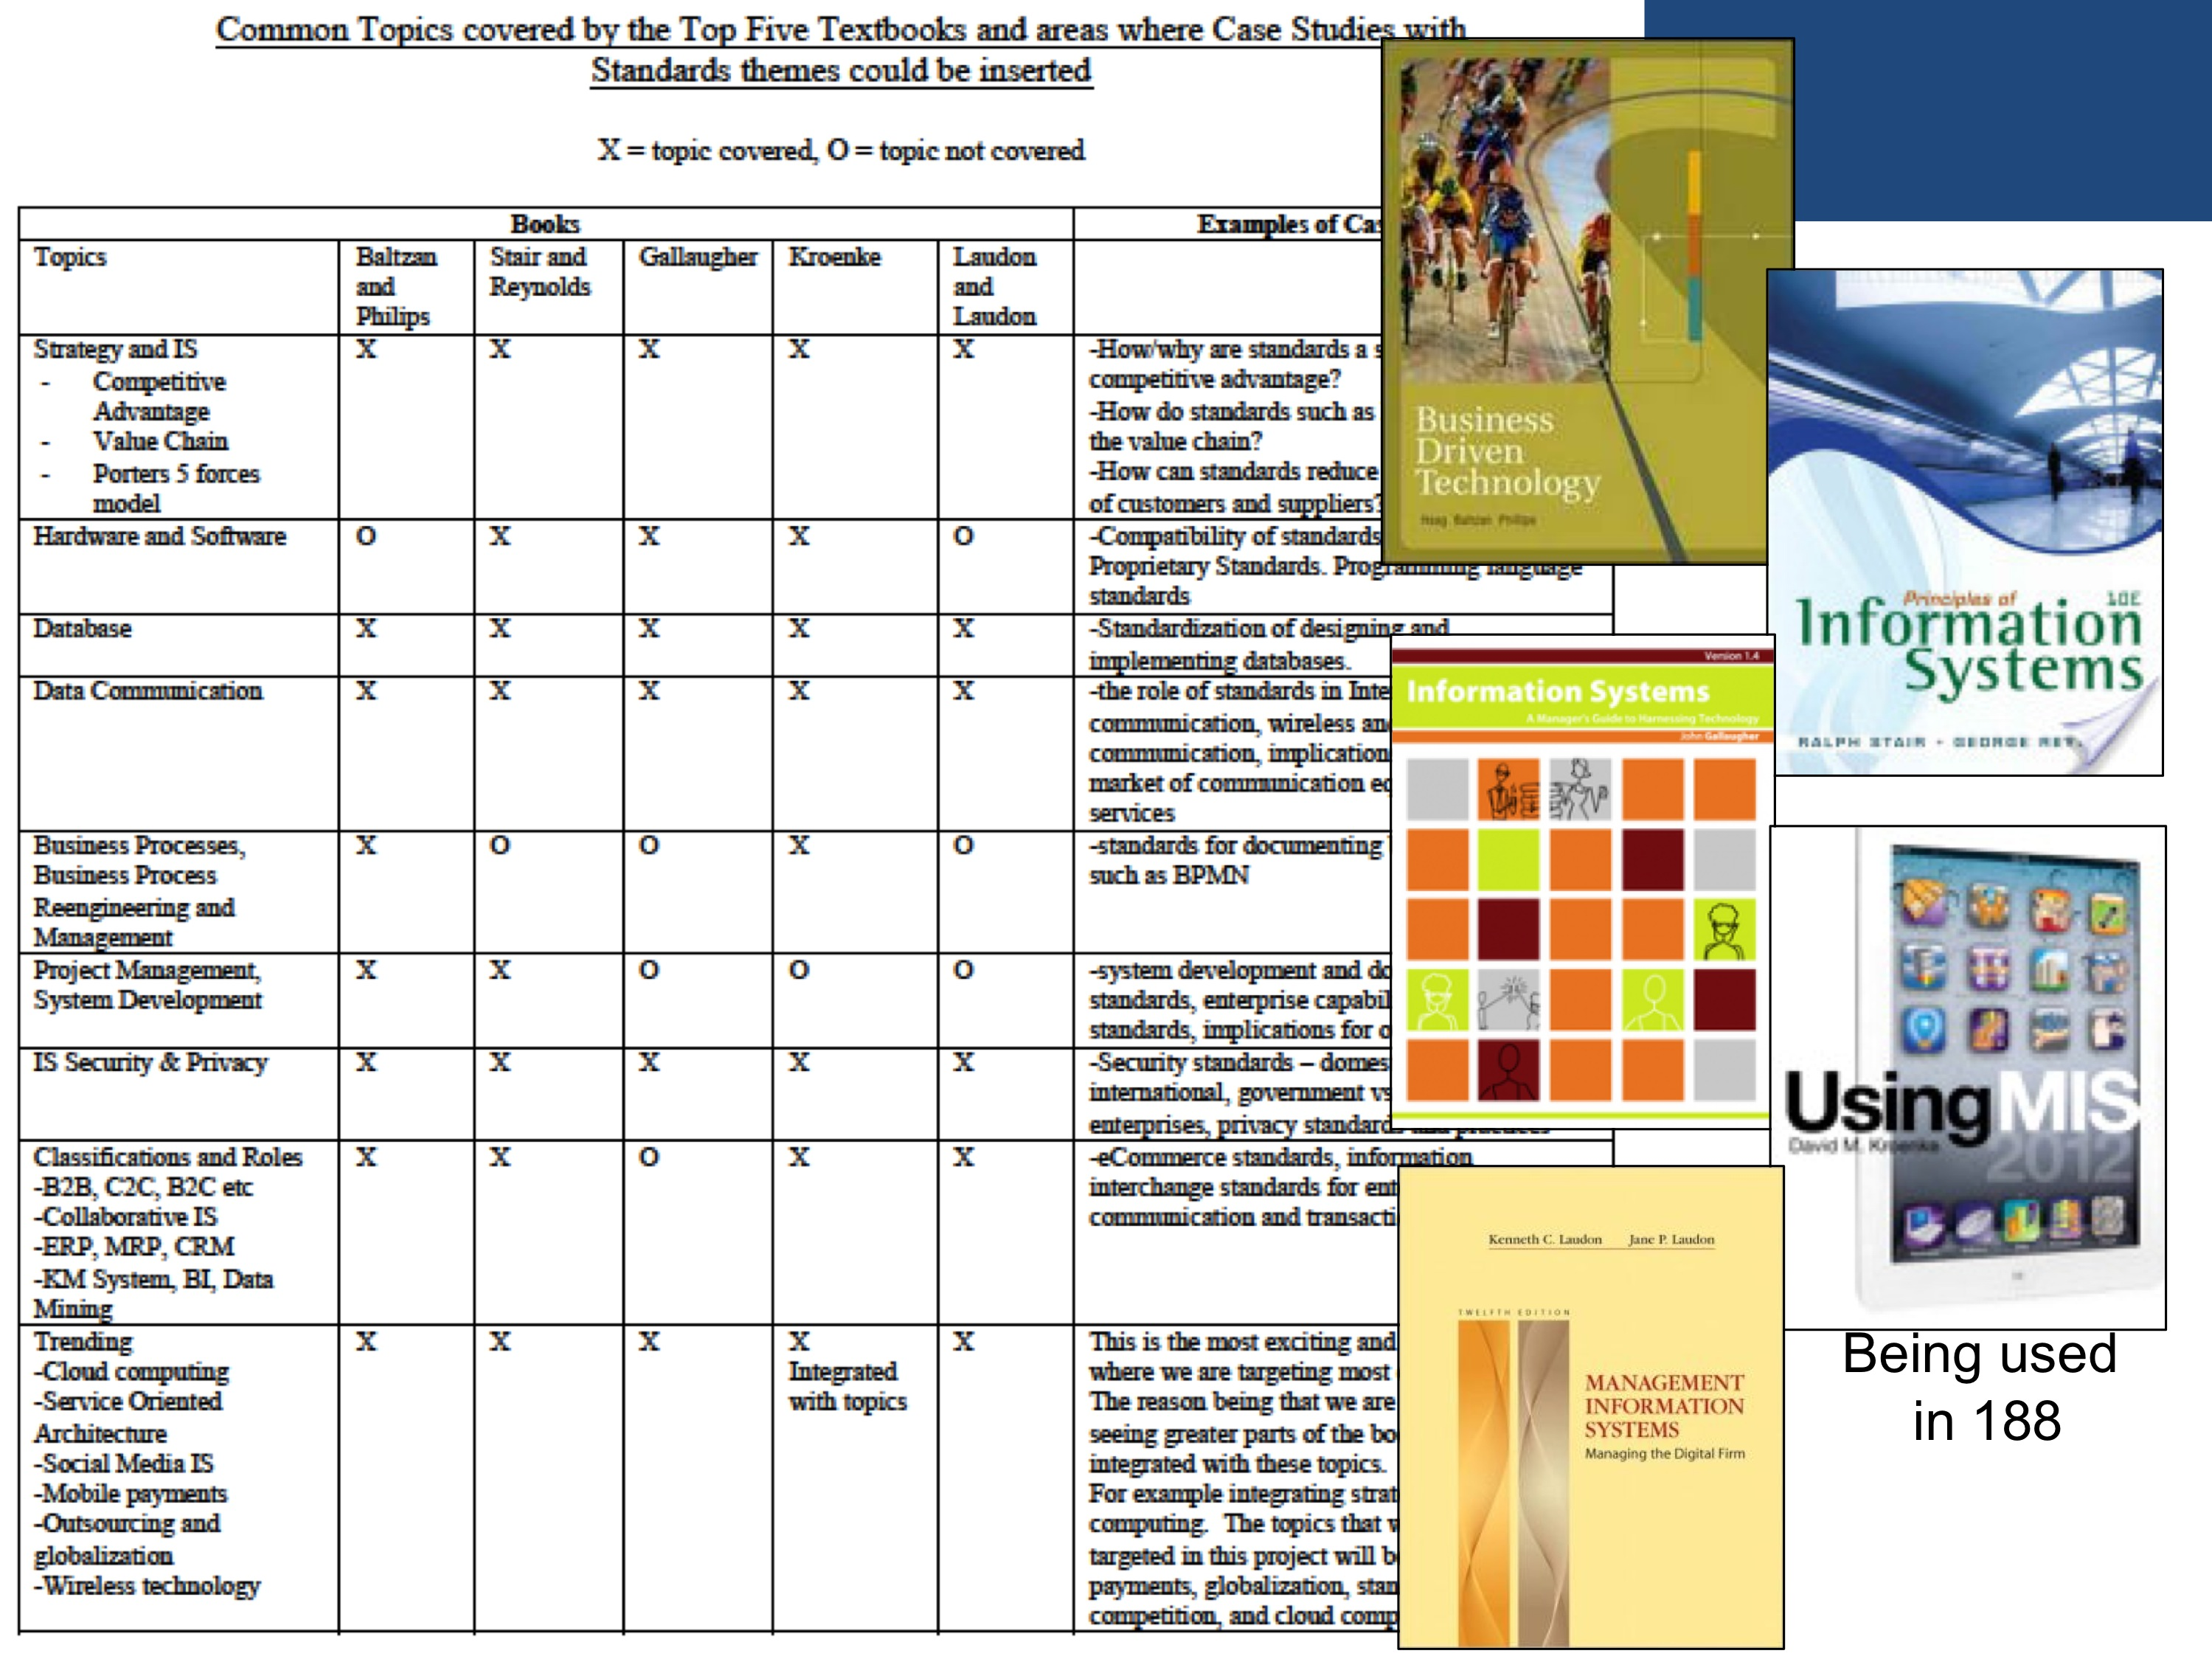
We have made some significant accomplishments since the last report. The cases are included at the end of this report.
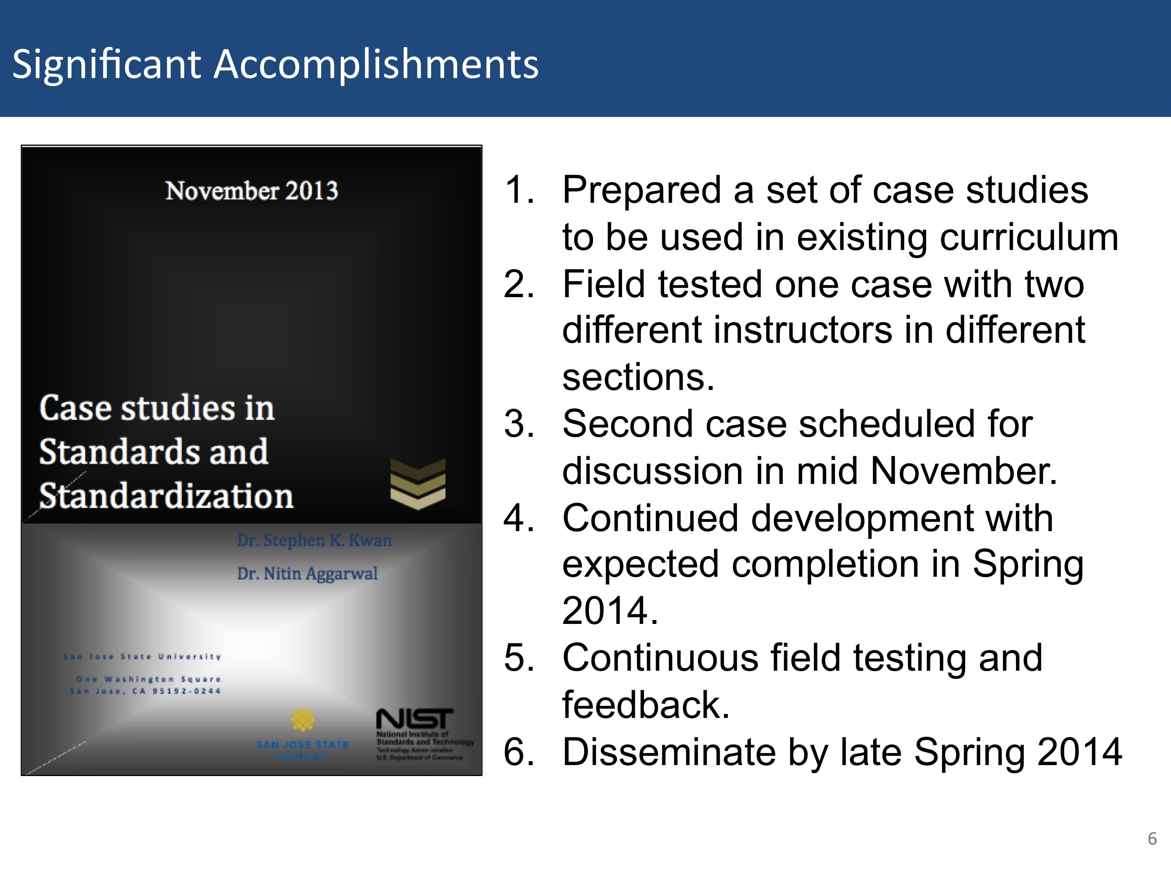
Case 1 on Software Defined Network “Is it real or is it SDN” has been completed.
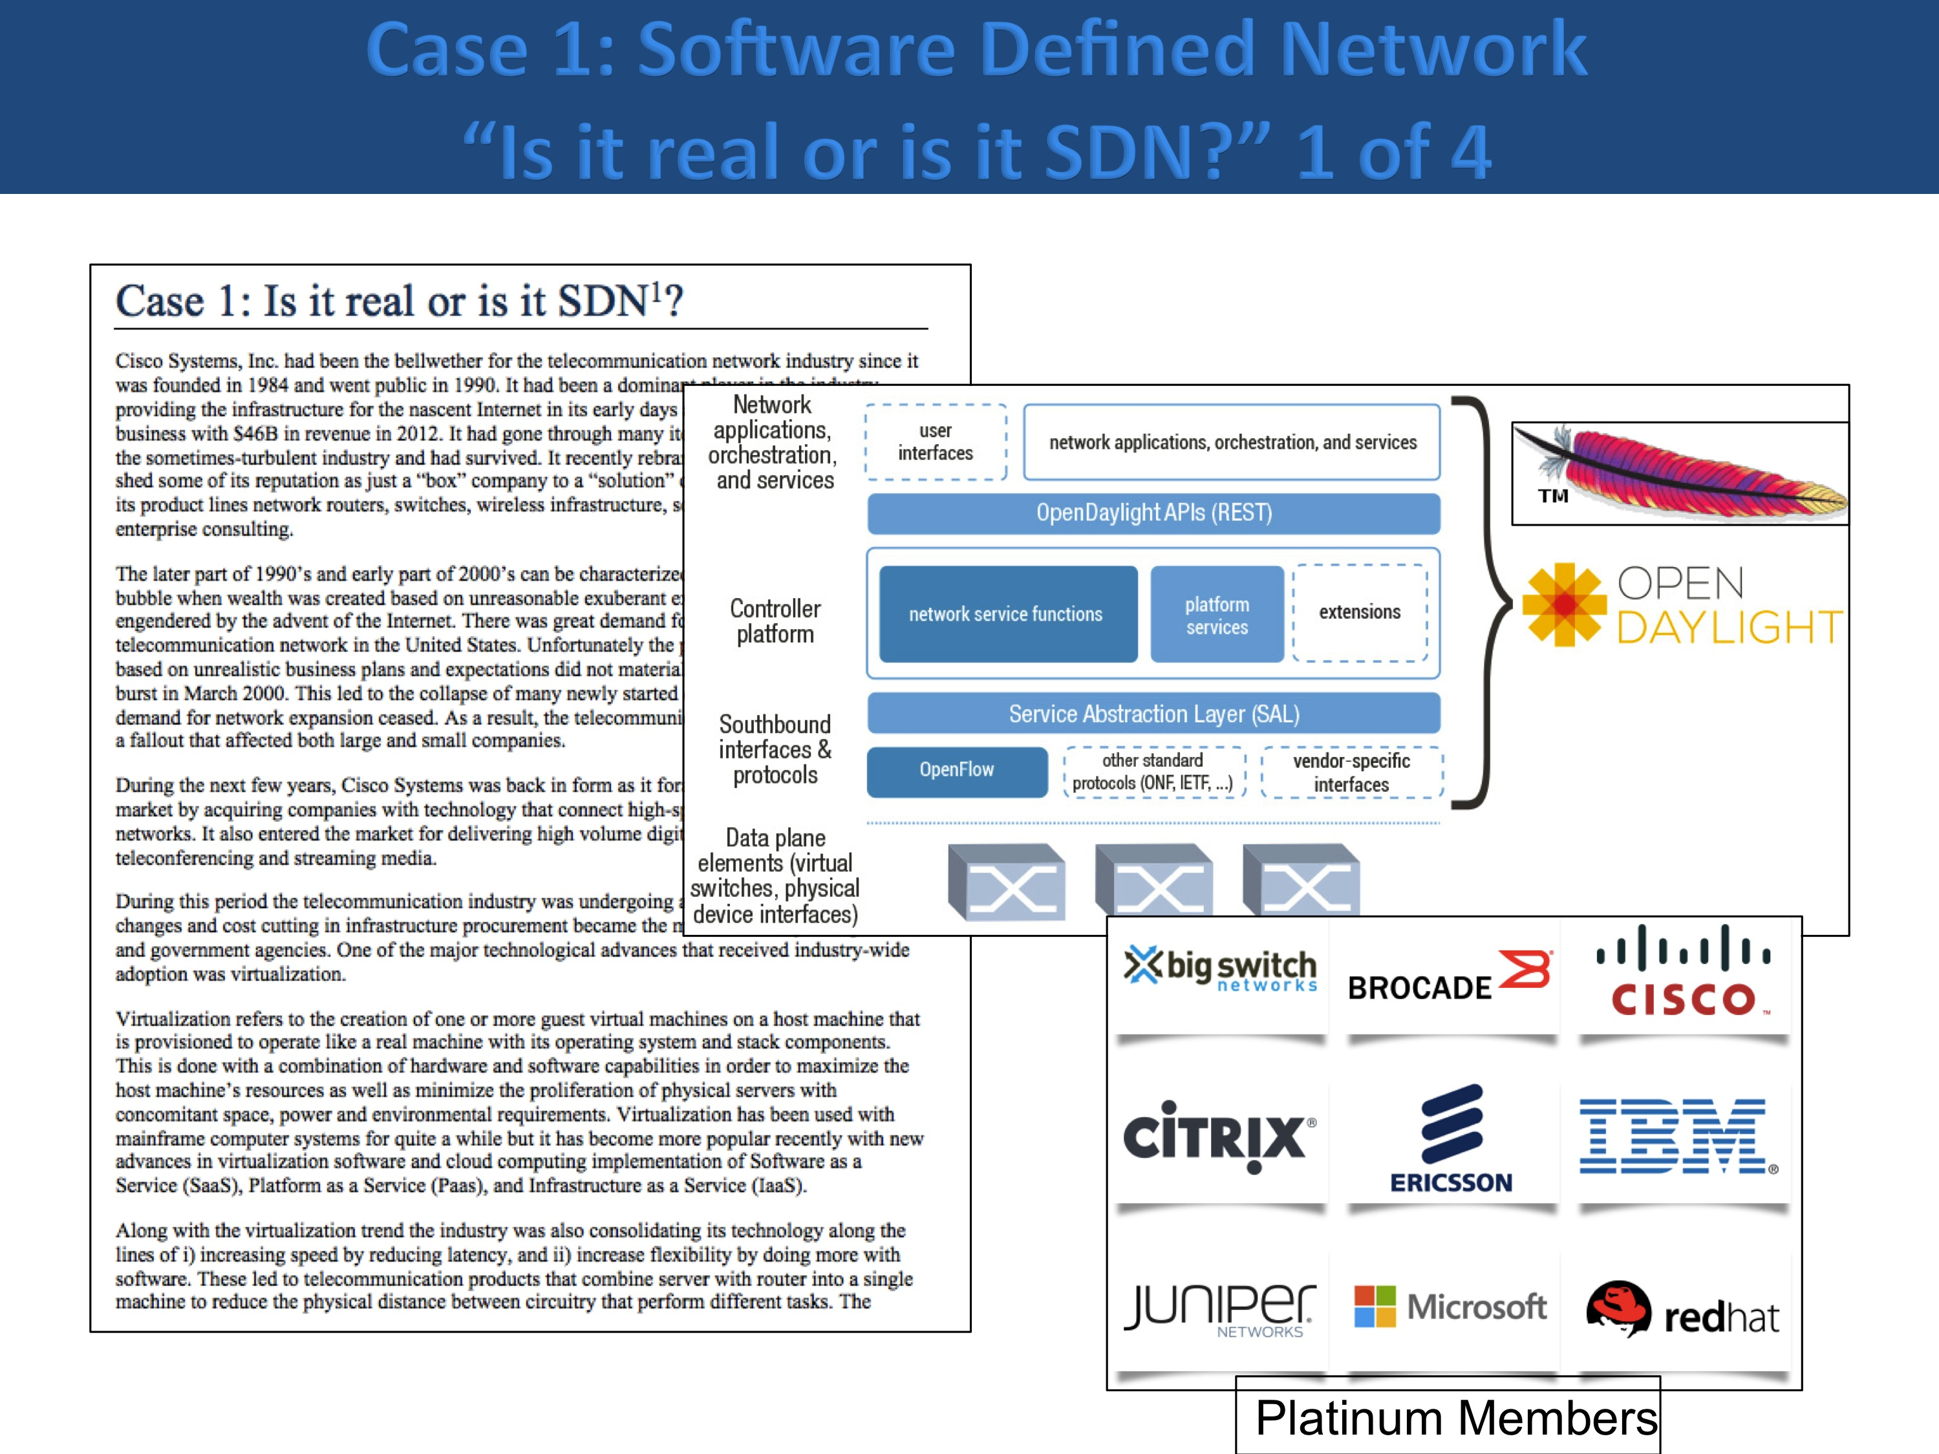
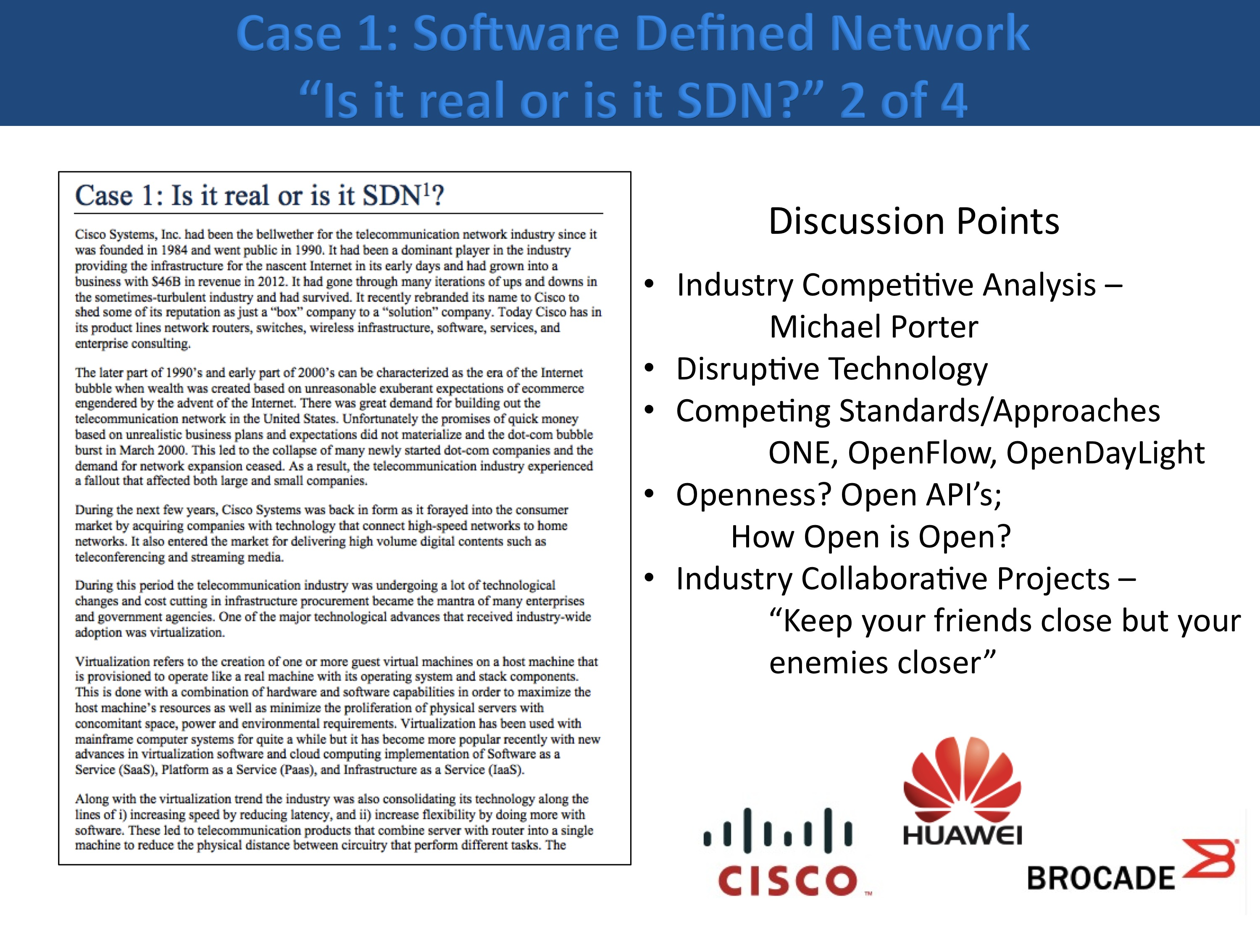
We have also enhanced the case with a news item from China about Brocade’s (a SDN vendor) push into the market. A key item in their pitch was that that their offerings support Open Standard (re: OpenDayLight). This example helped us in bringing in discussions about Open Standards and the role of Standards in international trade.
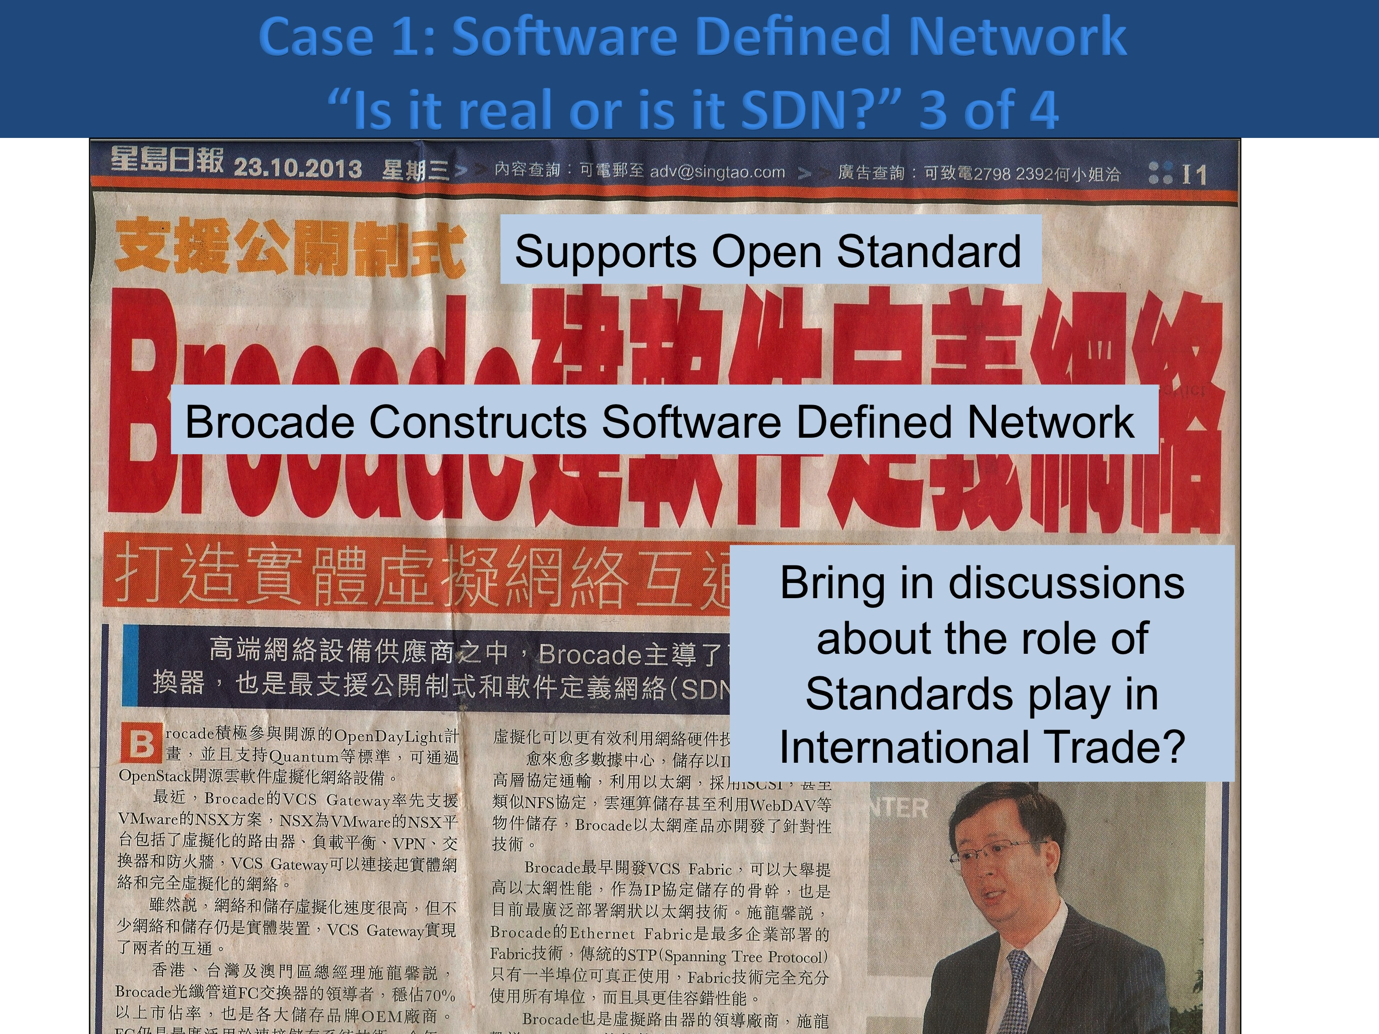
The case was also updated with a new diagram from OpenDayLight that shows the first release of a set of open API’s from the foundation. The technology was moving fast. It provided us with opportunities to ask students to update the case scenario based on the most current news when we teach the case.
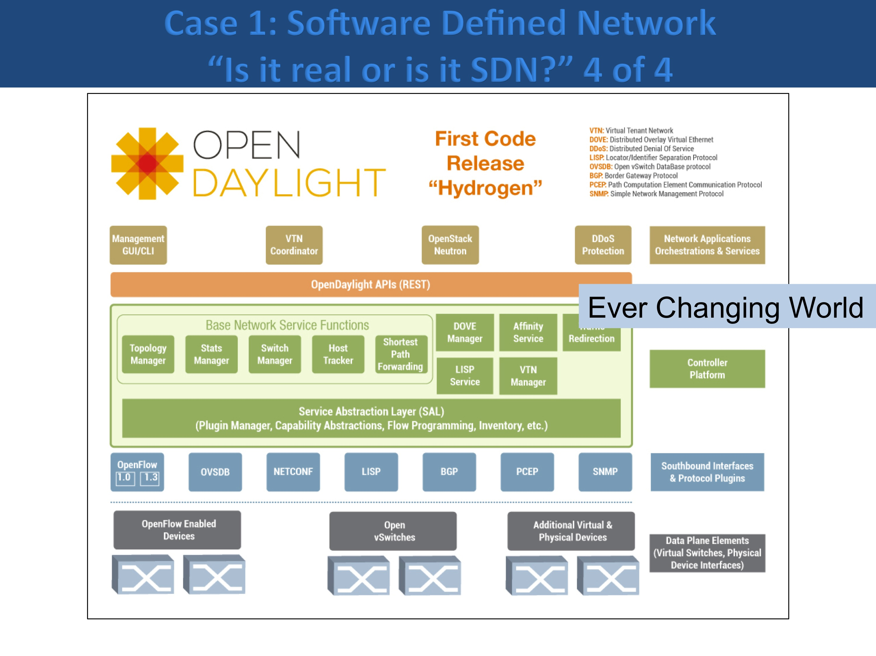
Case 2 about electric car chargers was completed and renamed “Charge it”.

Case 3 Wireless Payment – Wallet Share was completed and also enhanced with news items. We worked with two faculty members who taught the case in their BUS 188 classes.

Professor Scott Jensen spent considerable time in staging the case for his students. He assigned the case to the students to read at home and complete one of three quizzes based on the three technologies mentioned in the case: Google Wallet, ISIS and QR code.
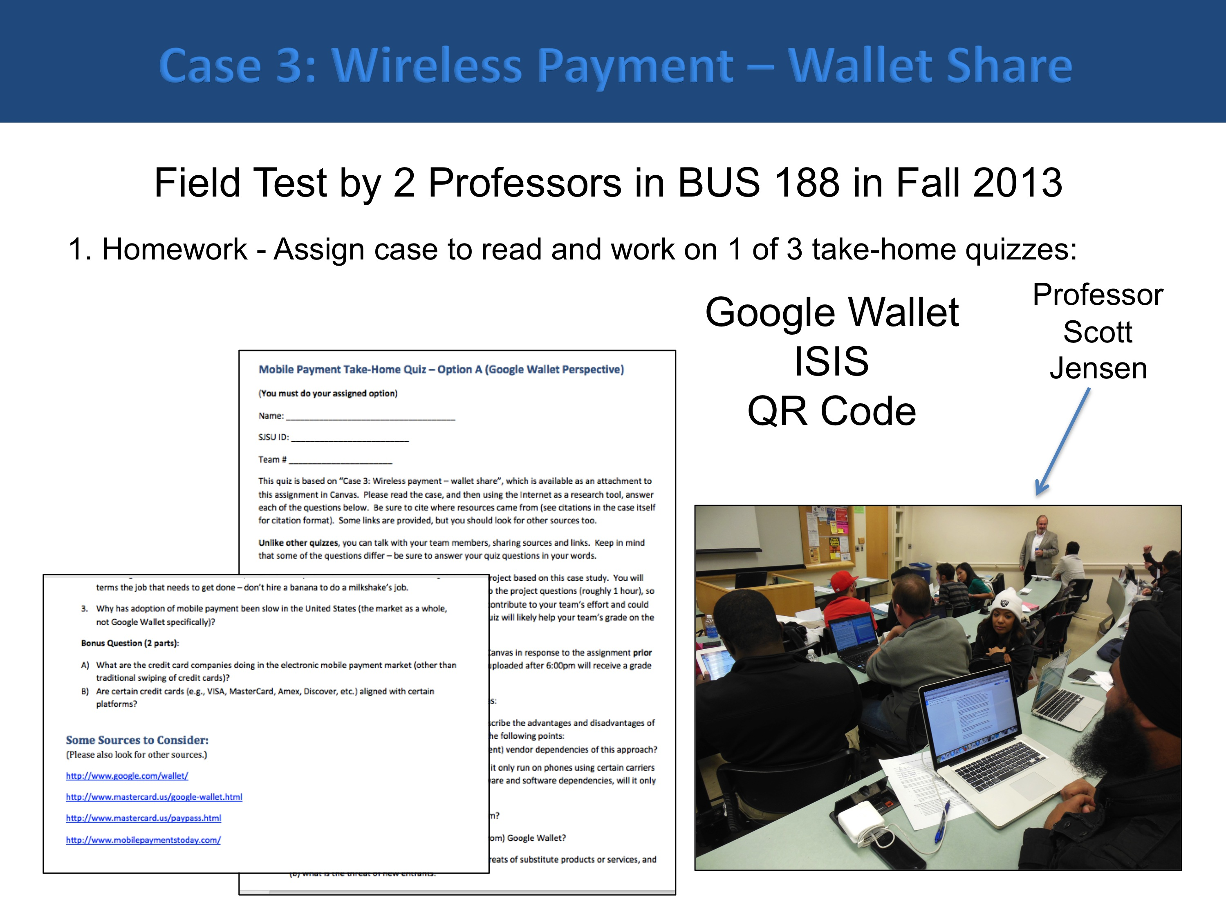
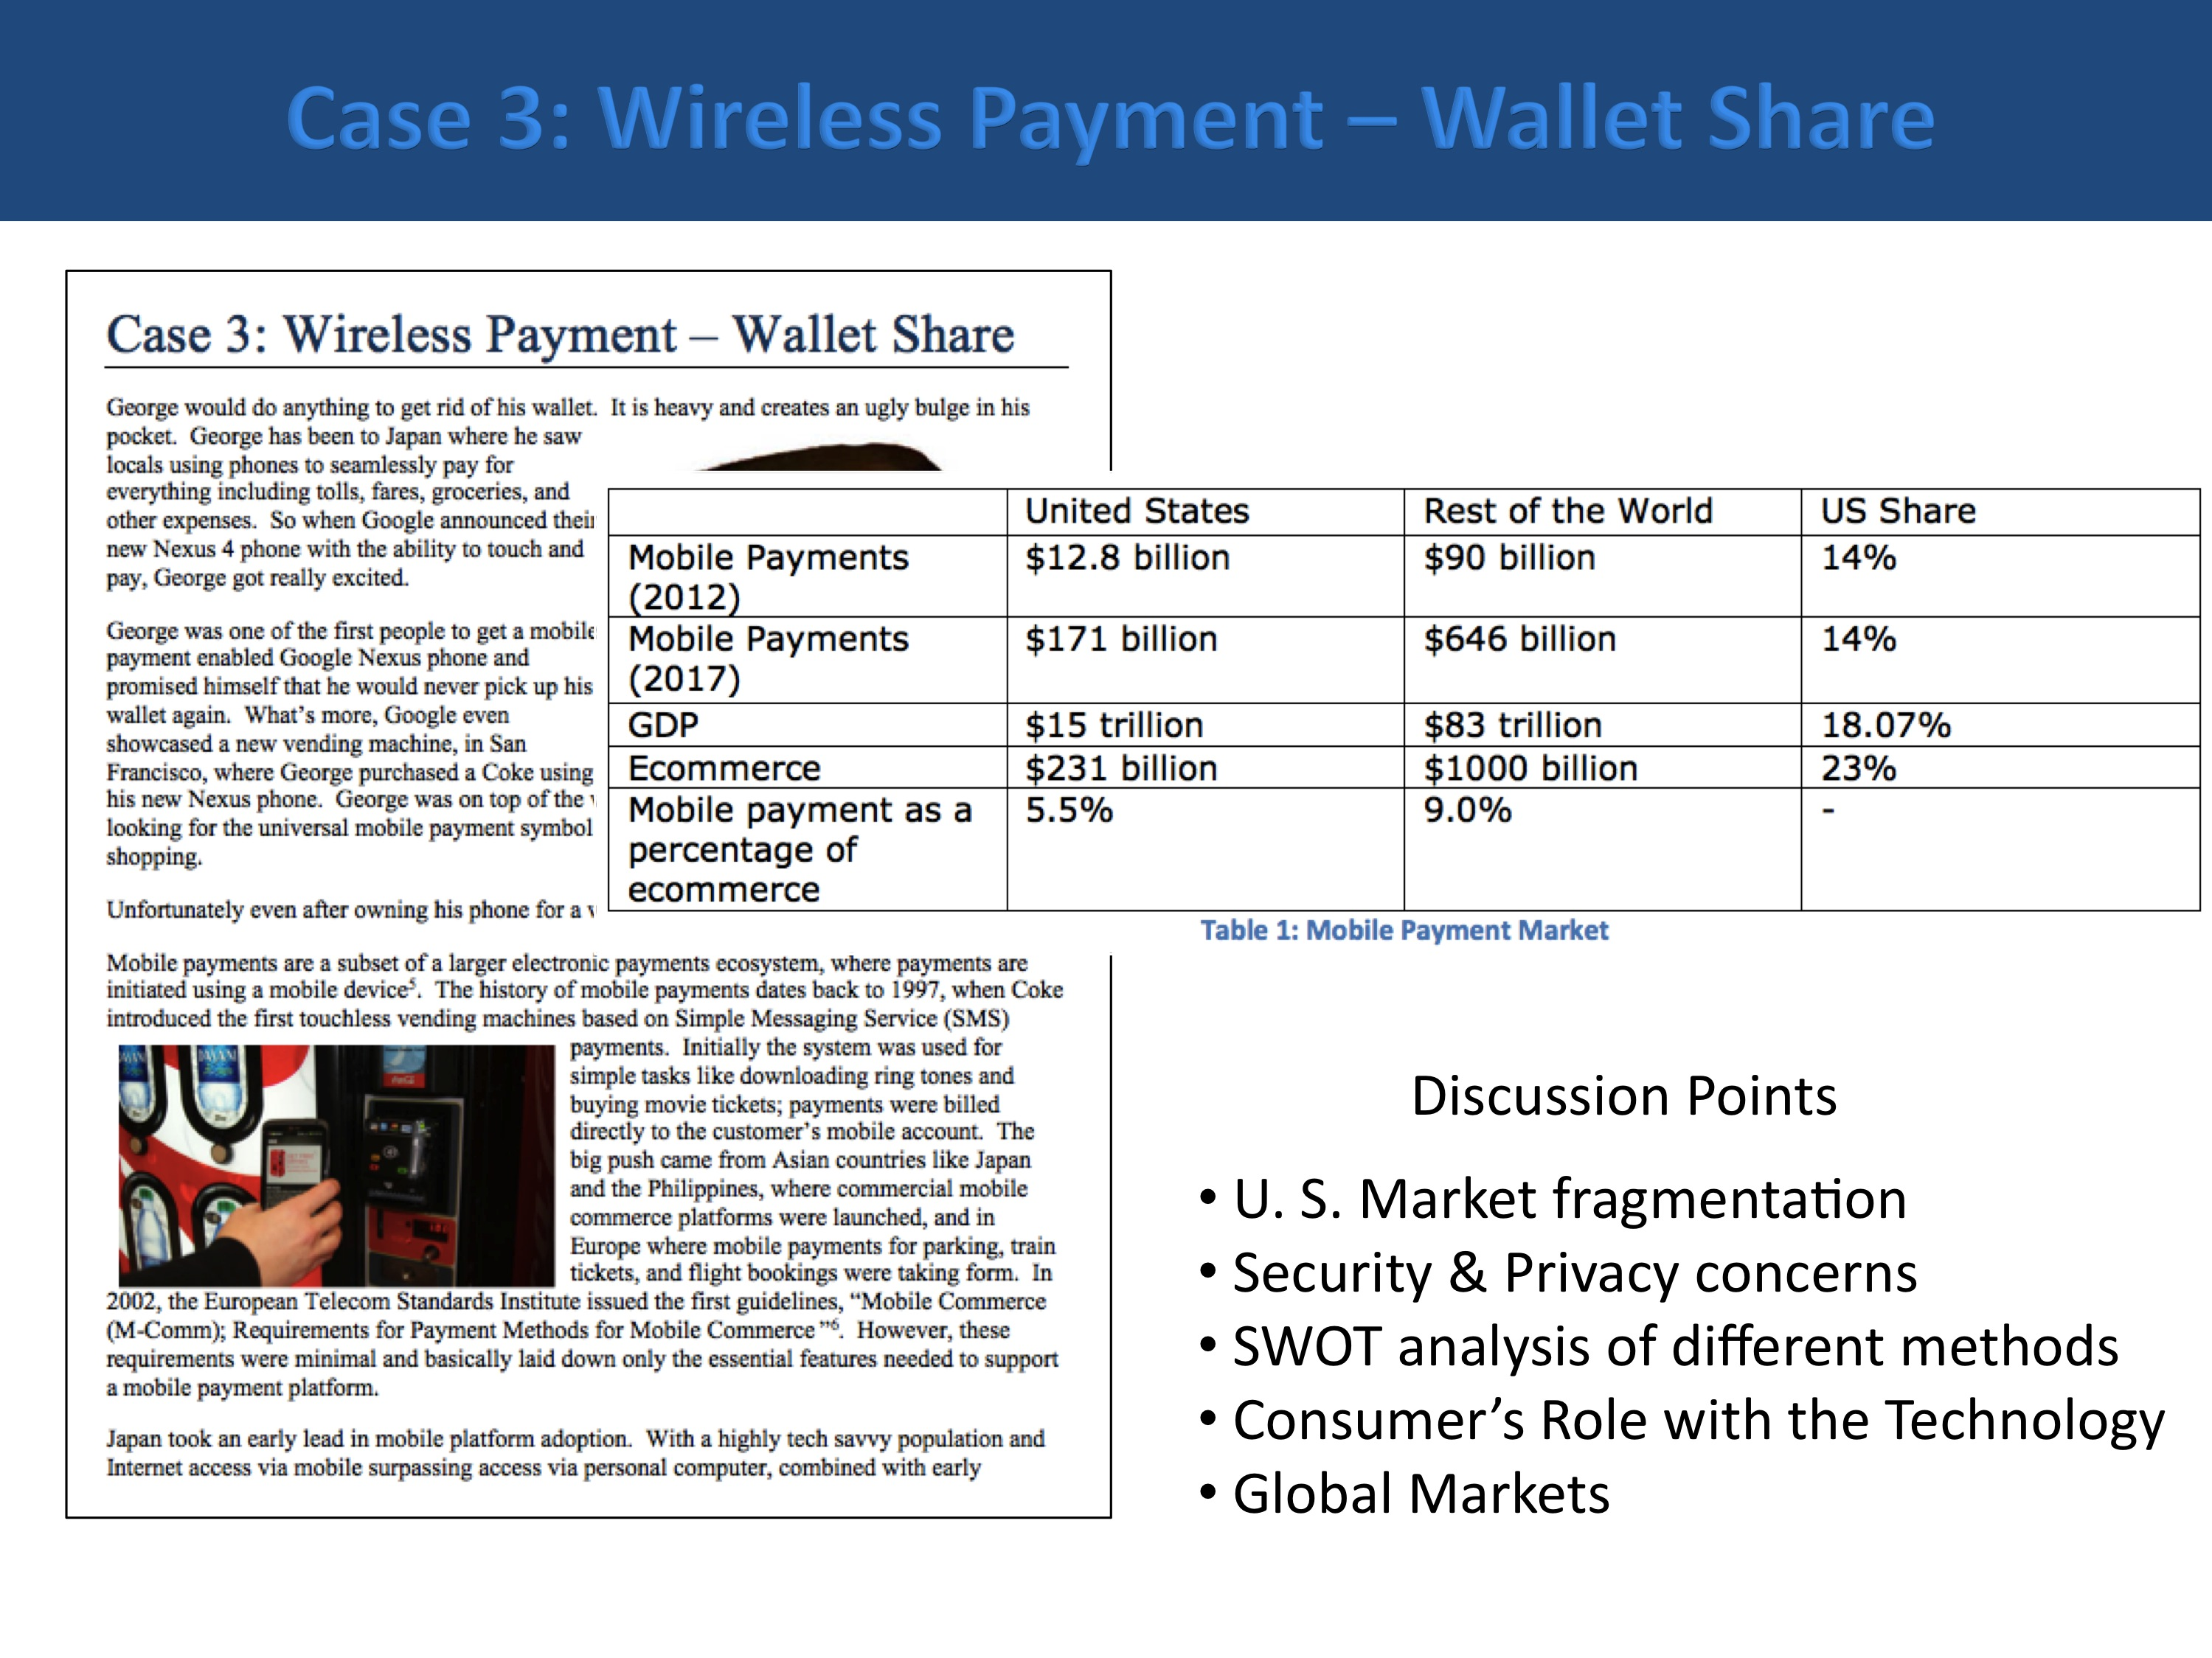
Professor Jensen also conducted the case analysis as an in-class team exercise. There were seven teams in the class and they had to present their answers to the questions below at the end of the class session. This allowed the students (who had done the research at home) to discuss more in-depth the different technologies and issues related to standards (or lack thereof). This is a good example of our “stealth insertion” approach. The students had good knowledge of the technologies involved and were led to discuss more about the market, competition, and the issues related to standards.
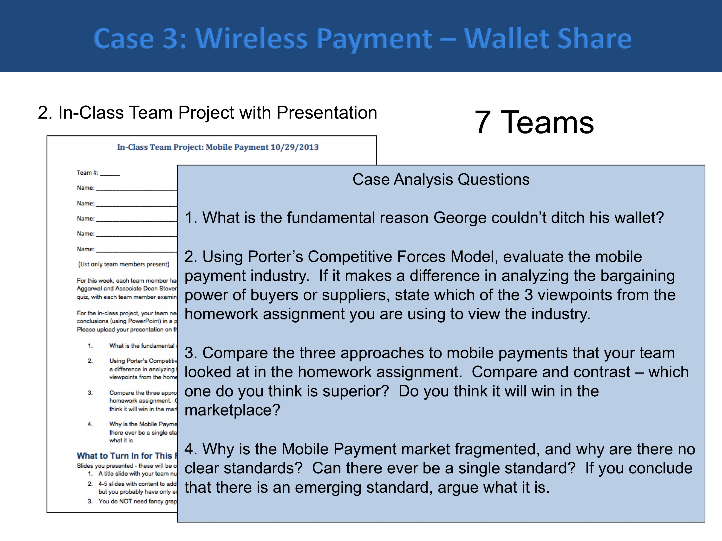
Professors Kwan and Aggarwal were present during the team discussions and they went from group to group to work with the students.
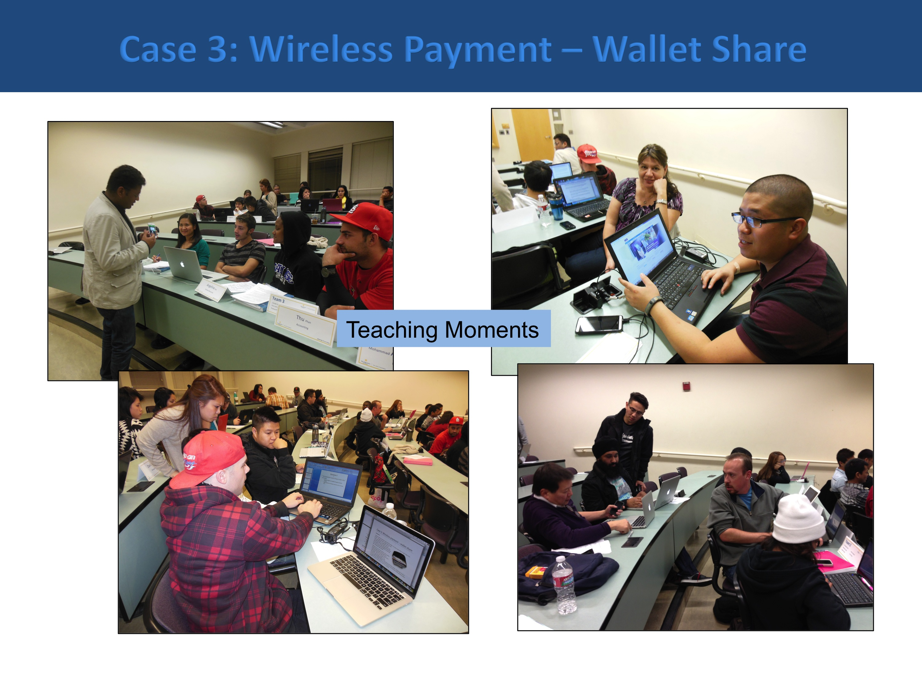
Each team made their presentations at the end of the class session.
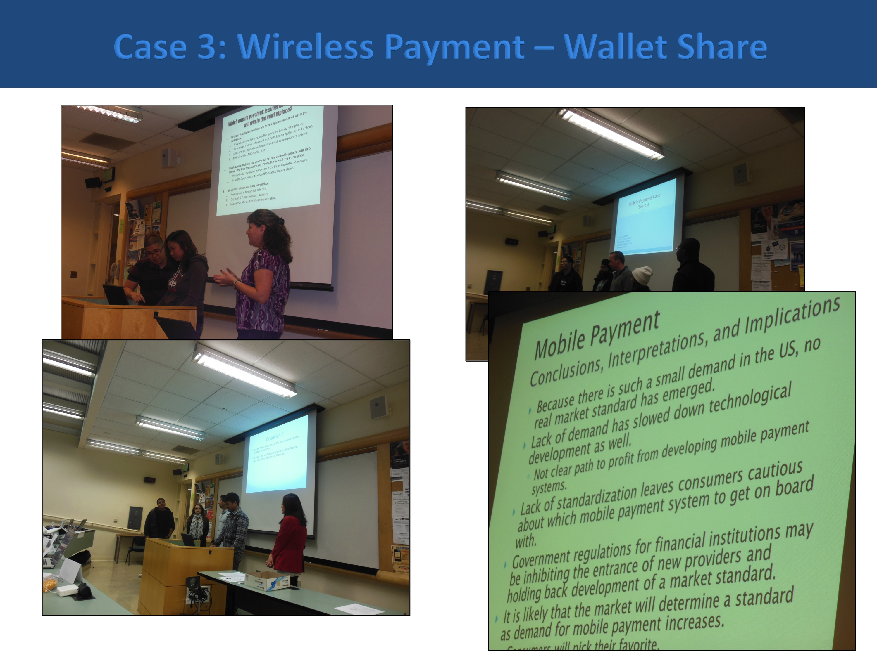
At the end of the exercise, we debriefed and summarized what we learned from the exercise.
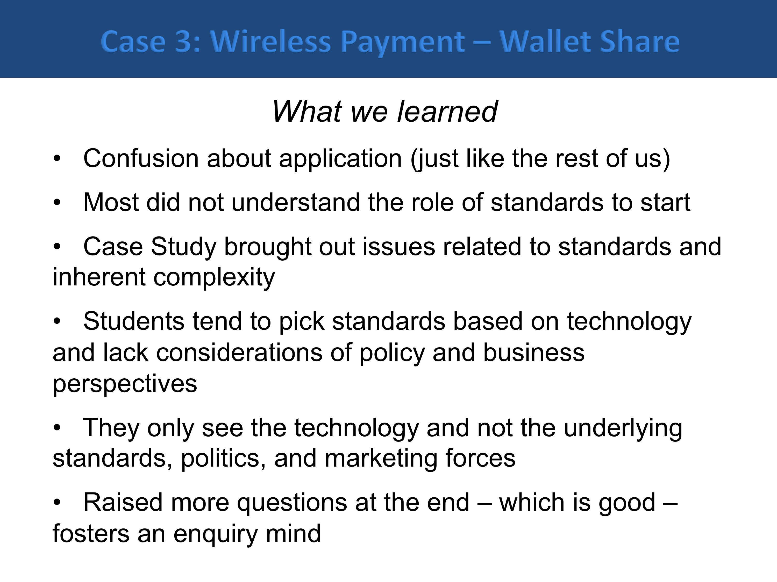
Professor Richard Session who taught a different section of BUS 188 also used the case in his class. His approach was different. He assigned the case to the students and required them to turn in a write-up with analysis and answers to the case questions. Two out-standing papers are shown below. A synopsis of what the students did is shown on the slide. We felt that the case successfully brought out the issues on standards we wanted to convey.
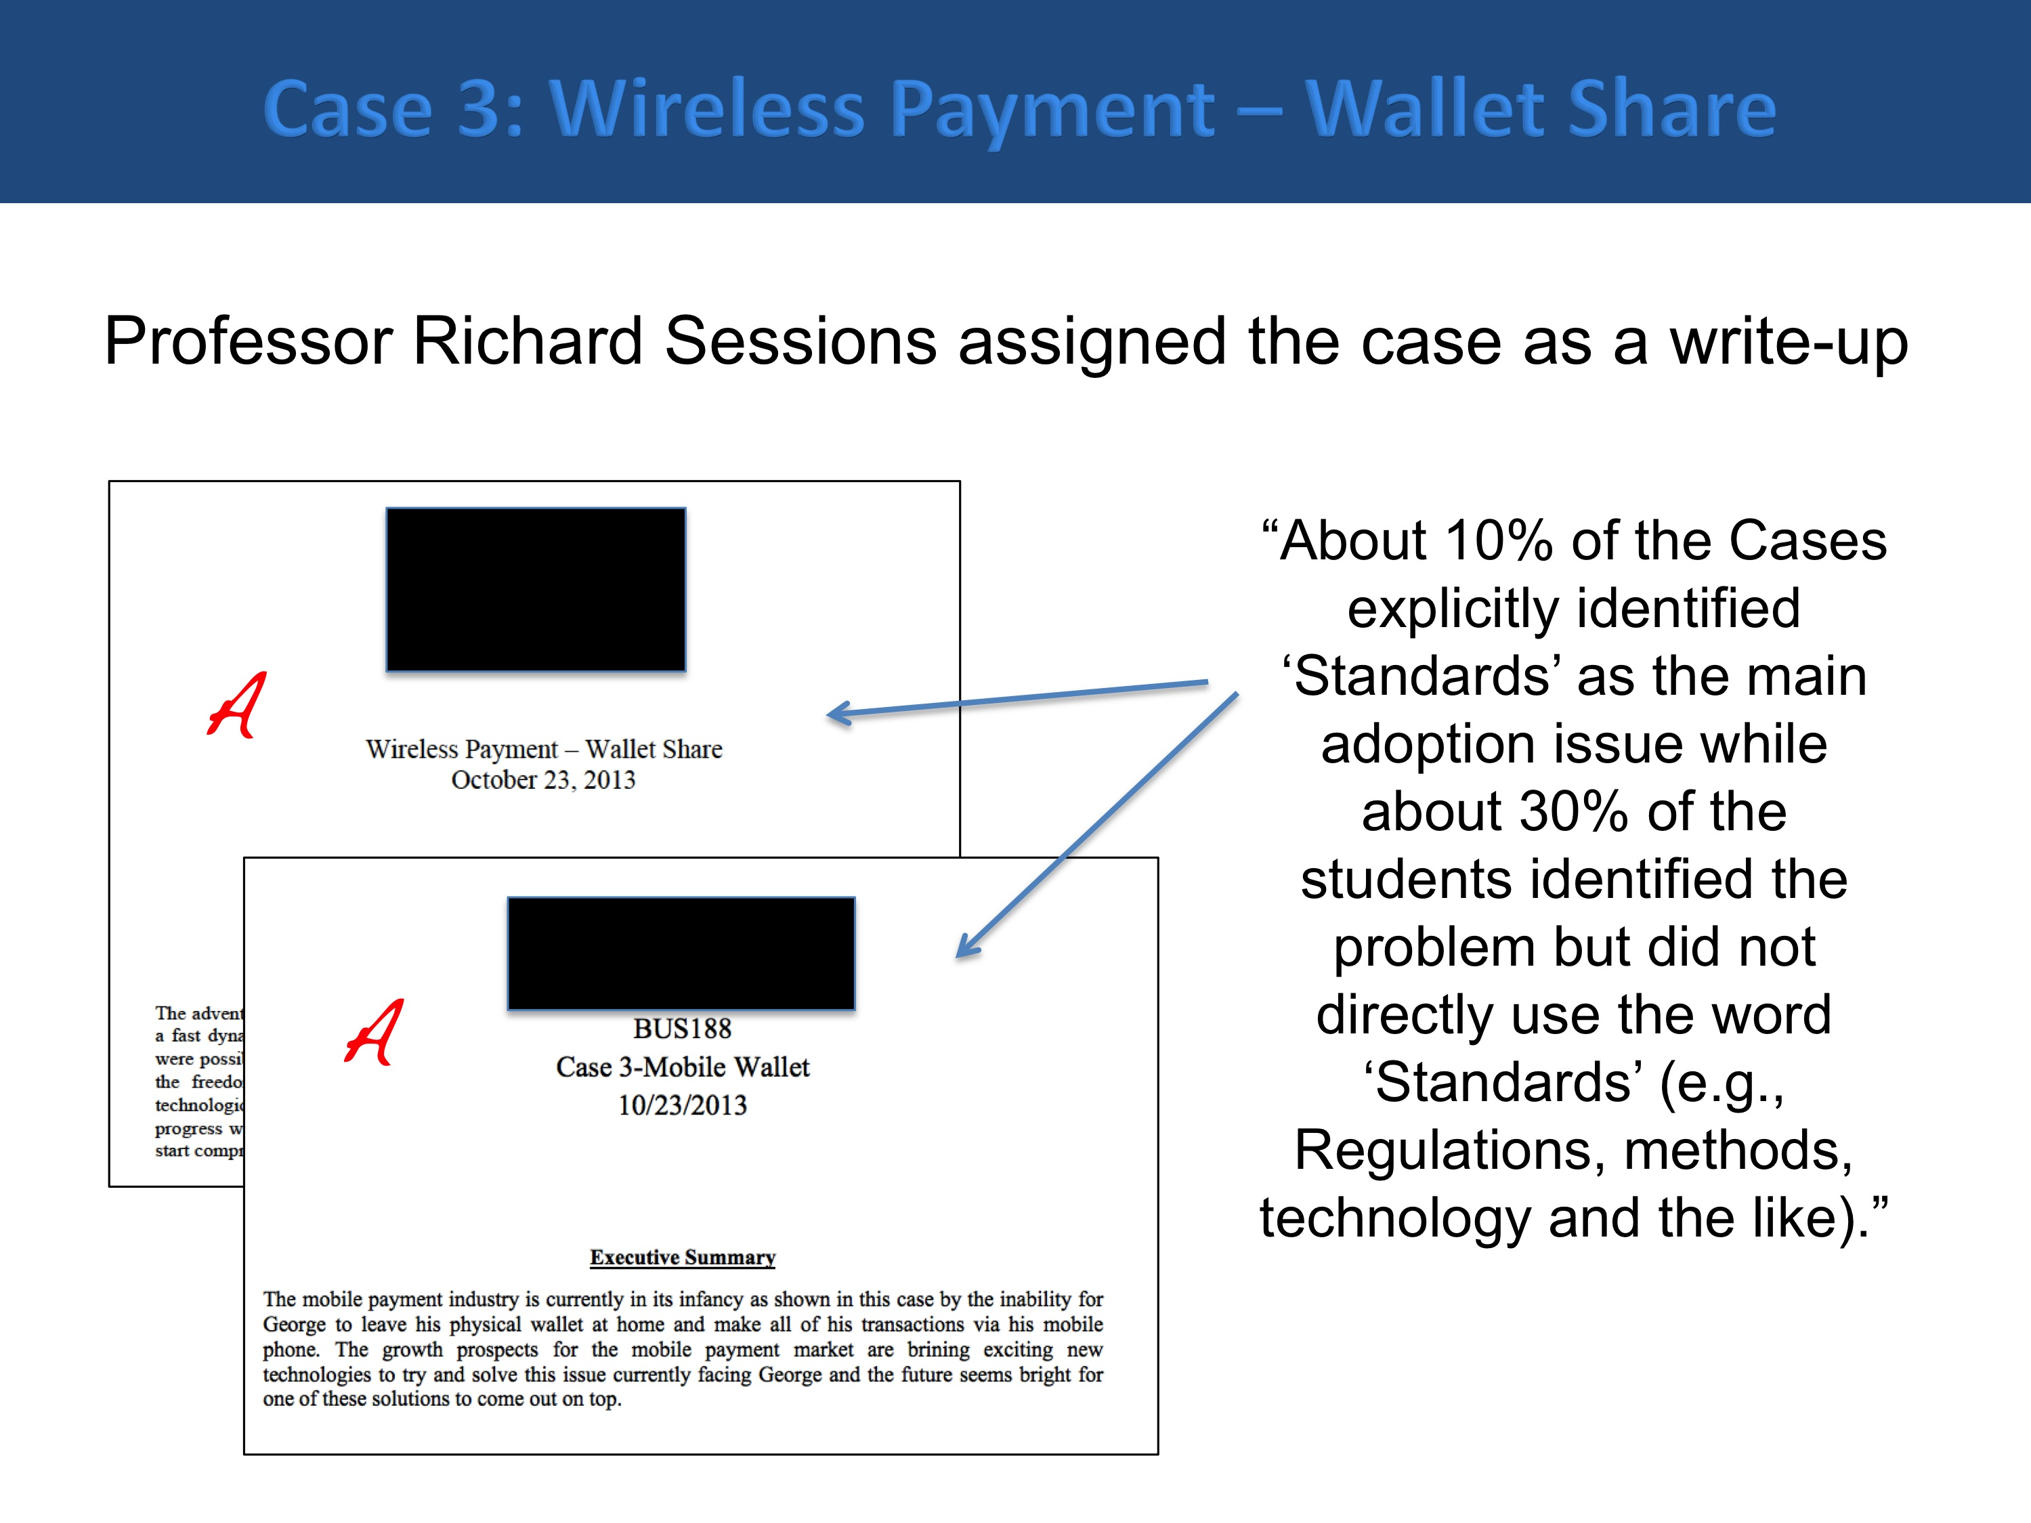
As part of our debrief we also noted the following points which would be used to enhance other cases as well as in writing case teaching notes for other instructors.
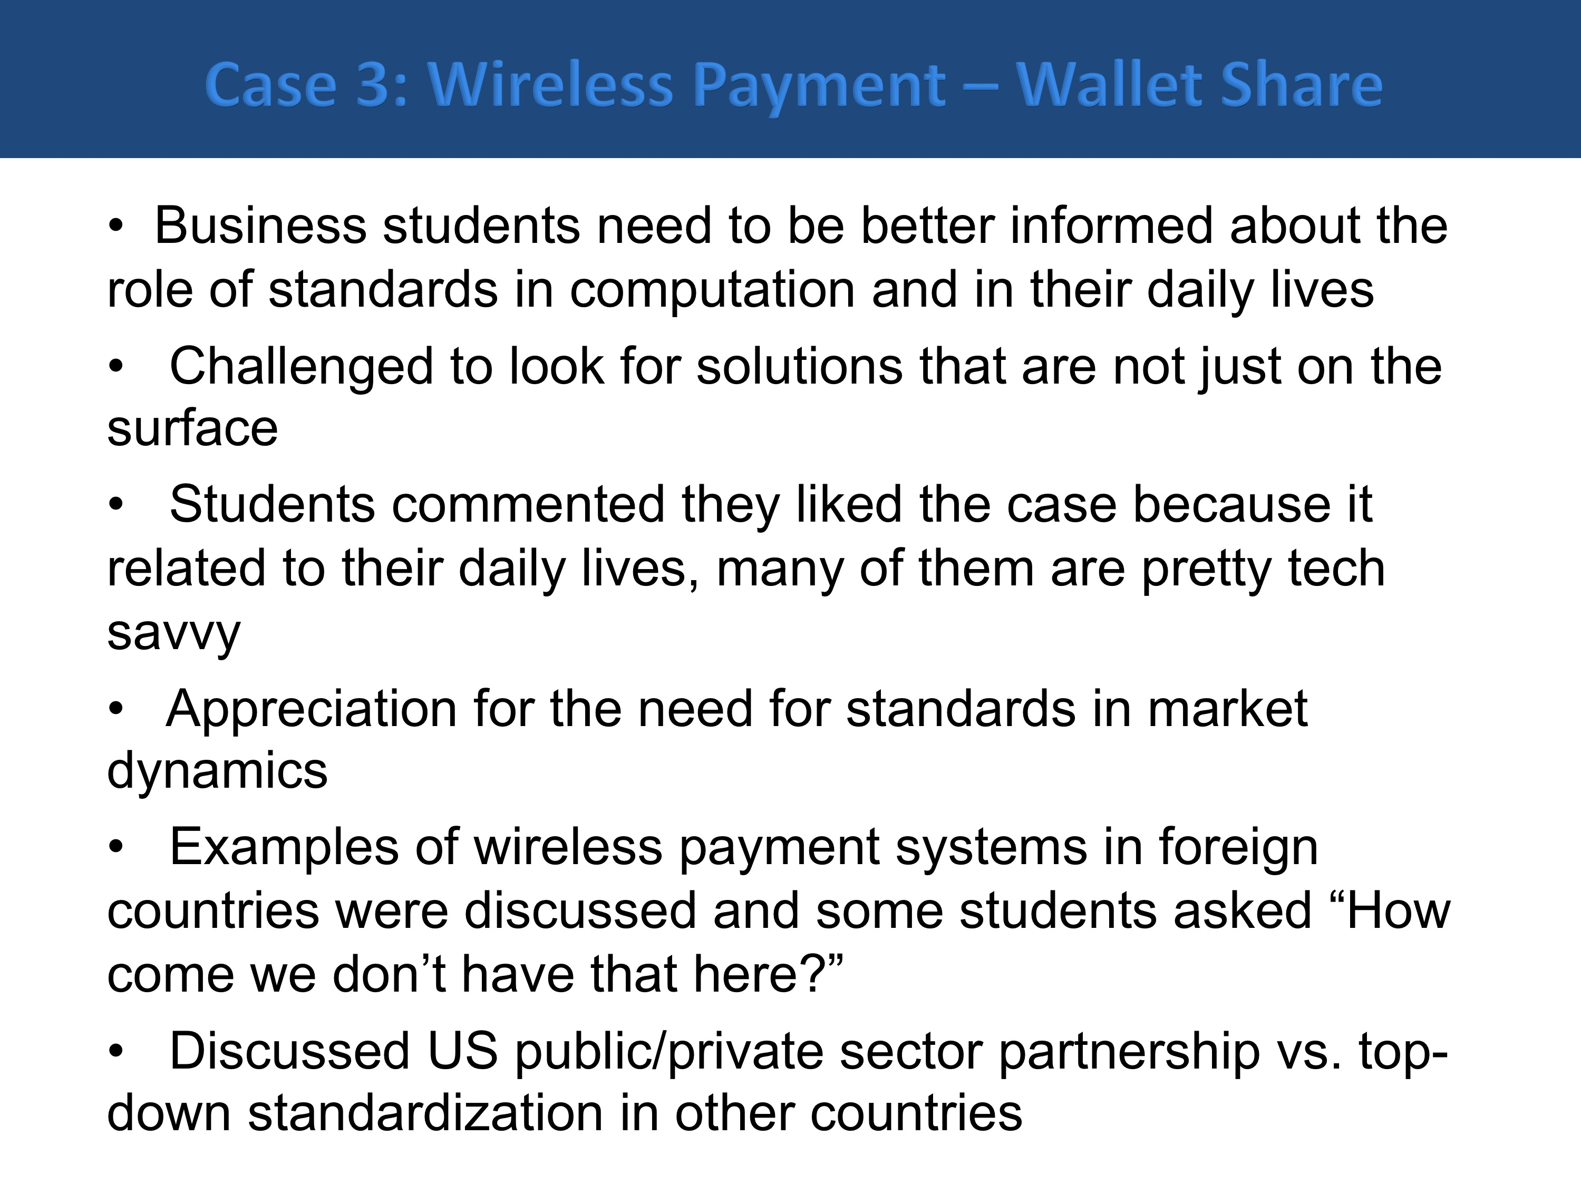
- Conclusion

We have developed six cases as part of this project and they are listed in Appendix C. “Case 6 – e-books – Not all are created equal” was an invited contribution to this collection from our colleague, Dr. Patricia Franks who is an Associate Professor in the School of Library and Information Sciences at SJSU. She shared our interest in promoting standards issues in our curriculum. We have made two invited presentations as part of this project. Professor Nitin Aggarwal also presented the results of this project recently at the 2014 Capstone Design Conference June 02-04, Columbus, Ohio by participating on a panel with theme of: "Case Studies in Use of Standards with Capstone Projects”.

The cases will be formatted into a printable booklet (both as a whole and as individual cases) to be made available online.

We sincerely thank NIST for providing the funding of this project as well as many of our colleagues who provided valuable comments and feedback. We want to express special thanks to Professor Scott Jensen and Professor Richard Sessions who were willing to test out our cases in their classes.
References
- Baltzan, P. and Philips, A. 2013. Business Driven Technology. McGraw-Hill.

Friedman, T. L. 2005. The World is Flat. Farrar, Strauss & Giroux.

Gallaugher, J. 2011. Information Systems: A Manager’s Guide to Harnessing Technology. Version 1.3. flatworld Knowledge.
- Kroenke, D. M. 2012. Using MIS. 4th ed. Pearson.

- Laudon, K. C. and Laudon, J. P. 2012. Management Information Systems. 12th ed. Pearson.

Levinson, M. 2008. The Box: How the Shipping Container Made the World Smaller and the World Economy Bigger. Princeton University Press.
- Stair, R. and Reynolds, G. 2012. Principles of Information Systems. 10th ed. Cengage Learning.

- Winkler, R. 2012. “Google Playing with Fire on Patents”. Wall Street Journal, June 4th, 2012, p. C16.

Appendix A
Common Topics covered by the Top Five Textbooks and areas where Case Studies with Standards themes could be inserted
X = topic covered, O = topic not covered
Books |  |  |  |  |  | Examples of Case Studies
Topics | Baltzan and Philips | Stair and Reynolds | Gallaugher | Kroenke | Laudon and Laudon
Strategy and IS  - Competitive Advantage  - Value Chain  - Porters 5 forces model | X | X | X | X | X | -How/why are standards a source of sustained competitive advantage?  -How do standards such as RFID contribute to the value chain?  -How can standards reduce bargaining power of customers and suppliers?
Hardware and Software | O | X | X | X | O | -Compatibility of standards. Open Standards. Proprietary Standards. Programming language standards
Database | X | X | X | X | X | -Standardization of designing and implementing databases.
Data Communication | X | X | X | X | X | -the role of standards in Internet communication, wireless and cell phone communication, implications for the global market of communication equipment and services
Business Processes, Business Process Reengineering and Management | X | O | O | X | O | -standards for documenting business processes such as BPMN
Project Management, System Development | X | X | O | O | O | -system development and documentation standards, enterprise capability and quality standards, implications for outsourcing
IS Security & Privacy | X | X | X | X | X | -Security standards – domestic and international, government vs. private enterprises, privacy standards and practices
Classifications and Roles  -B2B, C2C, B2C etc  -Collaborative IS  -ERP, MRP, CRM  -KM System, BI, Data Mining | X | X | O | X | X | -eCommerce standards, information interchange standards for enterprise communication and transactions
Trending  -Cloud computing  -Service Oriented Architecture  -Social Media IS  -Mobile payments  -Outsourcing and globalization  -Wireless technology | X | X | X | X Integrated with topics | X | This is the most exciting and upcoming area where we are targeting most of our efforts. The reason being that we are increasingly seeing greater parts of the books being tightly integrated with these topics.  For example integrating strategy with cloud computing. The topics that we identified to be targeted in this project will be mobile payments, globalization, standards and competition, and cloud computing.

Appendix B
Project Personnel
Co-PI: Stephen K. Kwan is Professor of Service Science and Management Information Systems in the College of Business at San José State University, USA. He was the founding chair of the MIS department and had served as the Senior Associate Dean of the College. He is currently working on the Service Science, Management, Engineering, and Design (SSMED) research and academic program at SJSU. He is very active in the SSMED community. He works closely with IBM on SSMED and is a recipient of IBM Faculty Awards. He is a member of the American National Standards Institute (ANSI) Committee on Education and was the secretariat of The International Cooperation for Education about Standardization (ICES). He was credentialed as an industry expert in the US Delegation to the APEC 2011 meeting in the US. He had also worked on projects with Sun Microsystems, Cisco, Microsoft, HP, the State of California, the US Army, etc. His current research interests include Global Trade in Services, Service Systems & Service Value Networks, and Design Thinking for Service System Innovation. He received a B.S. and M.S. in Computer Science from the University of Oregon, and a Ph.D. in Management from UCLA. He had published in the areas of Service Science, Queueing Systems, Database Management, E-Commerce, Standards Education and Standards Policy.
Co-PI: Nitin Aggarwal is Associate Professor of Business in the department of Management Information Systems at San José State University. He has published in MIS Quarterly, Decision Sciences, IJEC, and Electronic Markets. He has also presented his research in a number of national and international conferences such as ICIS, HICSS, and AMCIS. He is a member of the Association for Information Systems, the professional forum for IS professionals. Dr. Aggarwal is an active researcher in the area of standards and standardization. His research includes organizational and governance issues, intellectual property issues, transactional issues, and economic issues involved in standardization. He received his Ph.D. in Business Administration from Texas Tech University.
Institutional Capabilities
The undergraduate and graduate degree programs of the College of Business are accredited by the AACSB. The Co-PI’s will work with the College’s Director of Assessment and Associate Dean of Undergraduate Programs so that the standard assessment methods following AACSB guidelines will be used in this project. The Co-PI’s will also be working with the course coordinator of BUS4 188 and individual instructors of the course to try out the case studies, obtain feedback, and assess the materials’ effectiveness. The San José State University Research Foundation will administer the project budget.
Appendix C – List of Case Studies
Available in Part 2 of 2 of this report
Case 1 – Is it real or is it SDN?
Stephen K. Kwan and Nitin Aggarwal
Case 2 – Charge it!
Stephen K. Kwan and Nitin Aggarwal
Case 3 – Wireless Payment – Wallet Share
Stephen K. Kwan and Nitin Aggarwal
Case 4 – Incompatibility in Mobile Chargers – Need Based or Strategic?
Stephen K. Kwan and Nitin Aggarwal
Case 5 – Apple vs. Samsung – The War of the Titans
Stephen K. Kwan and Nitin Aggarwal
Case 6 – E-Books – Not all are created equal! (invited contribution)
Patricia Franks, Associate Professor, School of Information, SJSU

In this, the term standard is used to refer to “standards and standardization”.
cf. Friedman 2005.
Accreditation Board for Engineering and Technology.
Often offered as an Introduction to Management Information Systems (MIS) course.
The Association to Advance Colleges and Schools of Business: the premier accreditation organization for business curriculum. Currently there are only 711 accredited business programs in 47 countries (June 2014).
We are basing this on some of our college’s Program Learning Goals. Each AACSB accredited program has similar Goals.
Mailing list of the Association for Information Systems (AIS) – the professional organization of Information Systems faculty. It currently has 3800 members.
The co-PIs are either members of, affiliated or partnered with these professional organizations.
http://www.standardslearn.org/ (retrieved June 1st, 2012). http://www.nist.gov/public_affairs/edguide.cfm (retrieved June 1st, 2012). http://www.standards-education.org/ (retrieved June 1st, 2012). http://www.ewh.ieee.org/soc/es/ (retrieved June 1st, 2012).
http://creativecommons.org (retrieved June 1st, 2012).
For example, a social networking site using Ning (http://www.ning.com/).
Using the same learning objective assessment technique we employ for assessing core courses in our curriculum for accreditation purposes.

