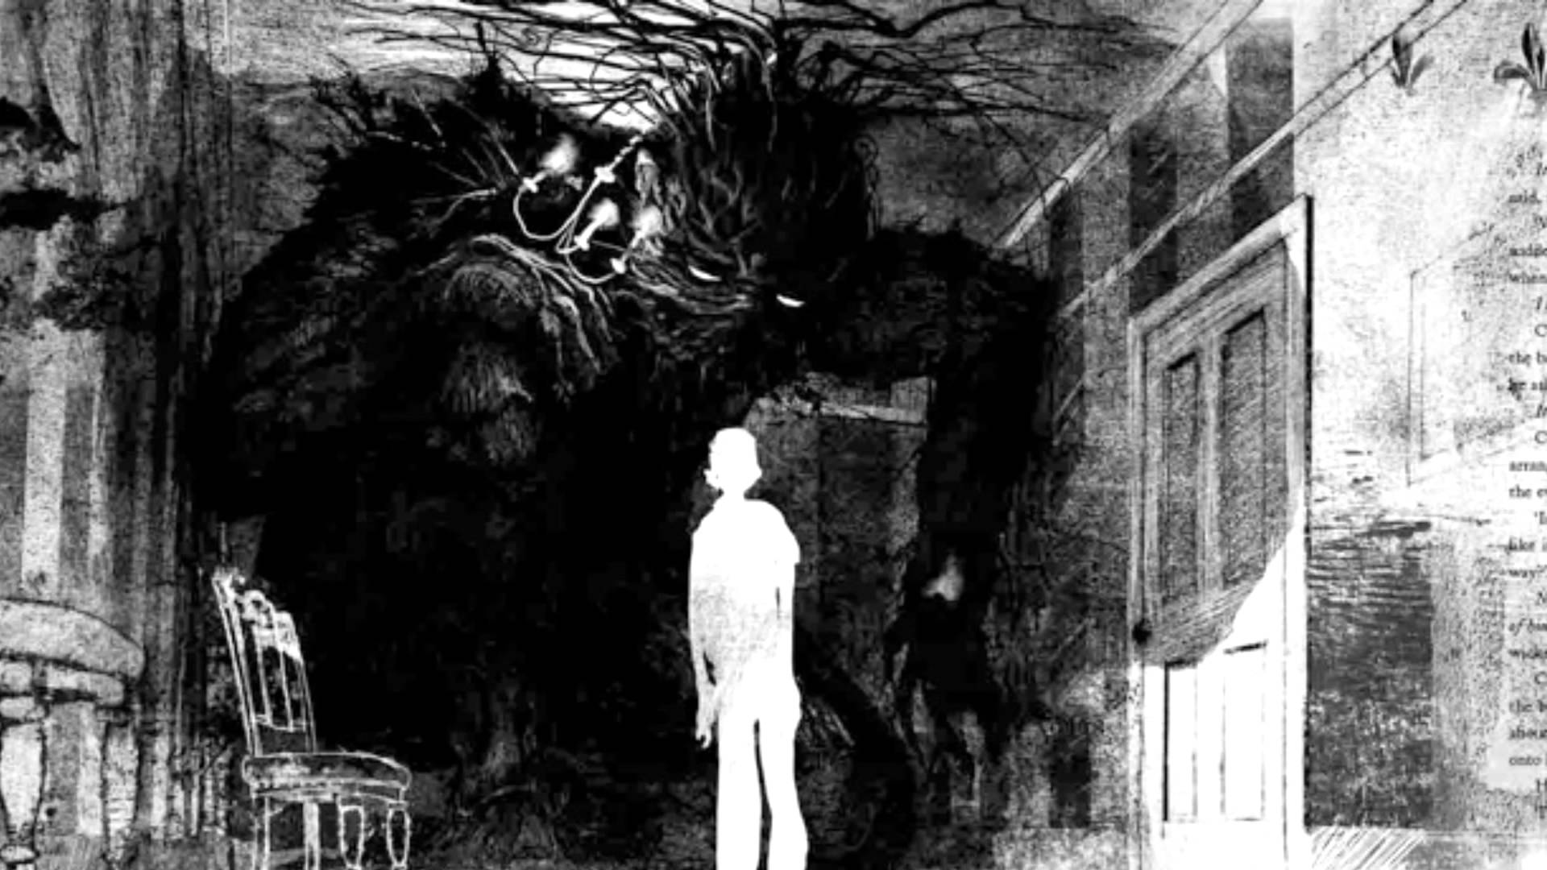

A Monster Calls
By Patrick Ness


Website: http://patrickness.com/

Patrick Ness has claims three different states in America as his home. He was born in Virginia, spent his junior high and high school years in Washington, and went to college in California. In 1999 he moved to the United Kingdom where he has lived ever since. Ness has won many awards for his novels and also writes screenplays, including the movie version of A Monster Calls.

Quick Summary of the Novel

In the book A Monster calls a young boy named Conor O’Malley has issues that he faces daily. He is tough and has learned to be self-reliant over the years with a sick mother and mostly absent father. Due to bullying to family problems, Conor is not your stereotypical kid. This story is a journey in which Conor must face the monsters that he refuses to acknowledge. One night he wakes up to a large monster outside his window, but it is not the monster Conor has been dreading. This large treelike creature tell Conor that he will tell him three stories, and then by the end of those stories Conor will tell the yew tree monster the truth about his nightmare. Through this experience Conor deals with the complexities of terrible truths as he tries to navigate his own life.

Quotes
Chapter one:

“He'd had a nightmare. Well, not a nightmare. The nightmare. The one he'd been having a lot lately. The one with the darkness and the wind and the screaming. The one with the hands slipping from his grasp, no matter how hard he tried to hold on.”
***
This quote is significant because Conor is just beginning to explain the nightmare, but is also refusing to tell us whose screaming he hears and whose hands are slipping. It’s the foreshadowing to a much greater and universal problem throughout the book.

Chapter Six:

Conor frowned, and for a second the whole room seemed to get darker, for a second it felt like the whole house was shaking, for a second it felt like he could reach down and tear the whole floor right out of the dark and loamy earth – He blinked. His grandma was still waiting for a response.
“I’m not going to live with
you,” he said. “Conor –”
“I’m never going to live with you.”
“Yes, you are,” she said. “I’m sorry, but you are. And I know she’s trying to protect you, but I think it’s vitally important for you to know that when this is all over, you’ve got a home, my boy. With someone who’ll love you and care for you.”
“When this is all over,” Conor said, fury in his voice, “you’ll leave and we’ll be fine.”
“Conor –” And then they both heard from the sitting room, “Mum? Mum?” His grandma the kitchen so fast that Conor jumped back in surprise. He could hear his mum coughing and his grandma saying, “It’s okay, darling, it’s okay, shh, shh, shh.” He glanced back out of the kitchen window on his way to the sitting room. The monster was gone. His grandma was on the settee, holding on to his mum, rubbing her back as she threw up into a small bucket they kept nearby just in case.
***
This quote is pretty powerful because it shows the contrast between what Connor desires and the truth of the reality his mother is facing. It clues the audience in on what is happening with Conor, and goes into his deep inner emotions as he deals with his grandmother, the bringer of reality.

Chapter 24:

He remembered all the screaming and running. He remembered the other kids fleeing to get teachers. He remembered the circle around him opening wider and wider as the monster told the story of all that he’d done for the
invisible man.

Never invisible again, the monster kept saying as he pummeled Harry. Never invisible again.

There came a point when Harry stopped trying to fight back, when the blows from the monster were too strong, too many, too fast, when he began begging the monster to stop. Never invisible again, the monster said, finally letting up, its huge branch-like fists curled tight as a clap of thunder. It turned to Conor. But there are harder things than being invisible, it said.
***
The journey through emotions is hard for young adults who aren’t used to navigating through tough emotions. So when they can’t take anymore it explodes out in one way or another. For Conor, the statement from his constant bully Henry pushes him over the edge. He feels lost, confused, and overlooked because of the illness he can’t ever bring himself to say. He lashes out and conflates with the yew tree monster as he pummels Henry with a newfound strength.

Literary Response
A Monster Calls is in the science fiction/fantasy genre of books that was published in 2011, and won a Carnegie Medal. Ness writes his characters show layers of complexity and depth. He skillfully uses imagery and creates a sense of magic, horror, and sadness in one heart-wrenching story. It meets all the Exeter Qualities, but mainly focuses on number 7, themes that allow the possibility of emotional and intellectual growth through engagement with personal issues, and number 1, Imaginative and well-structured plots going beyond simple chronologies to include time shifts and different perspectives.

Text Complexity

For the text complexity Lexile gives this book 730L. It also suggests the age range for 12-17 years olds and a comprehension rate of 75%. According to Dale-Chall, it’s score places at a complexity of 7.2 giving a recommended grade range of 9-10. This is the perfect age range for Young Adults. It features themes such as bullying, denial, isolation, and suffering. The implications in this novel are more than abundant and while it is easy enough to read, there are many aspects of it that call for the reader to dig deeper into the text itself and analyze what lies beyond the surface. High School is the perfect age range to teach this as kids are dealing with a lot of issues that stem from family crisis and conflict that can’t be avoided.

