Silas Cox
Dr. Mary Warner
ENGL 112B Sec 01
30 October 2023

The Song of Wrath
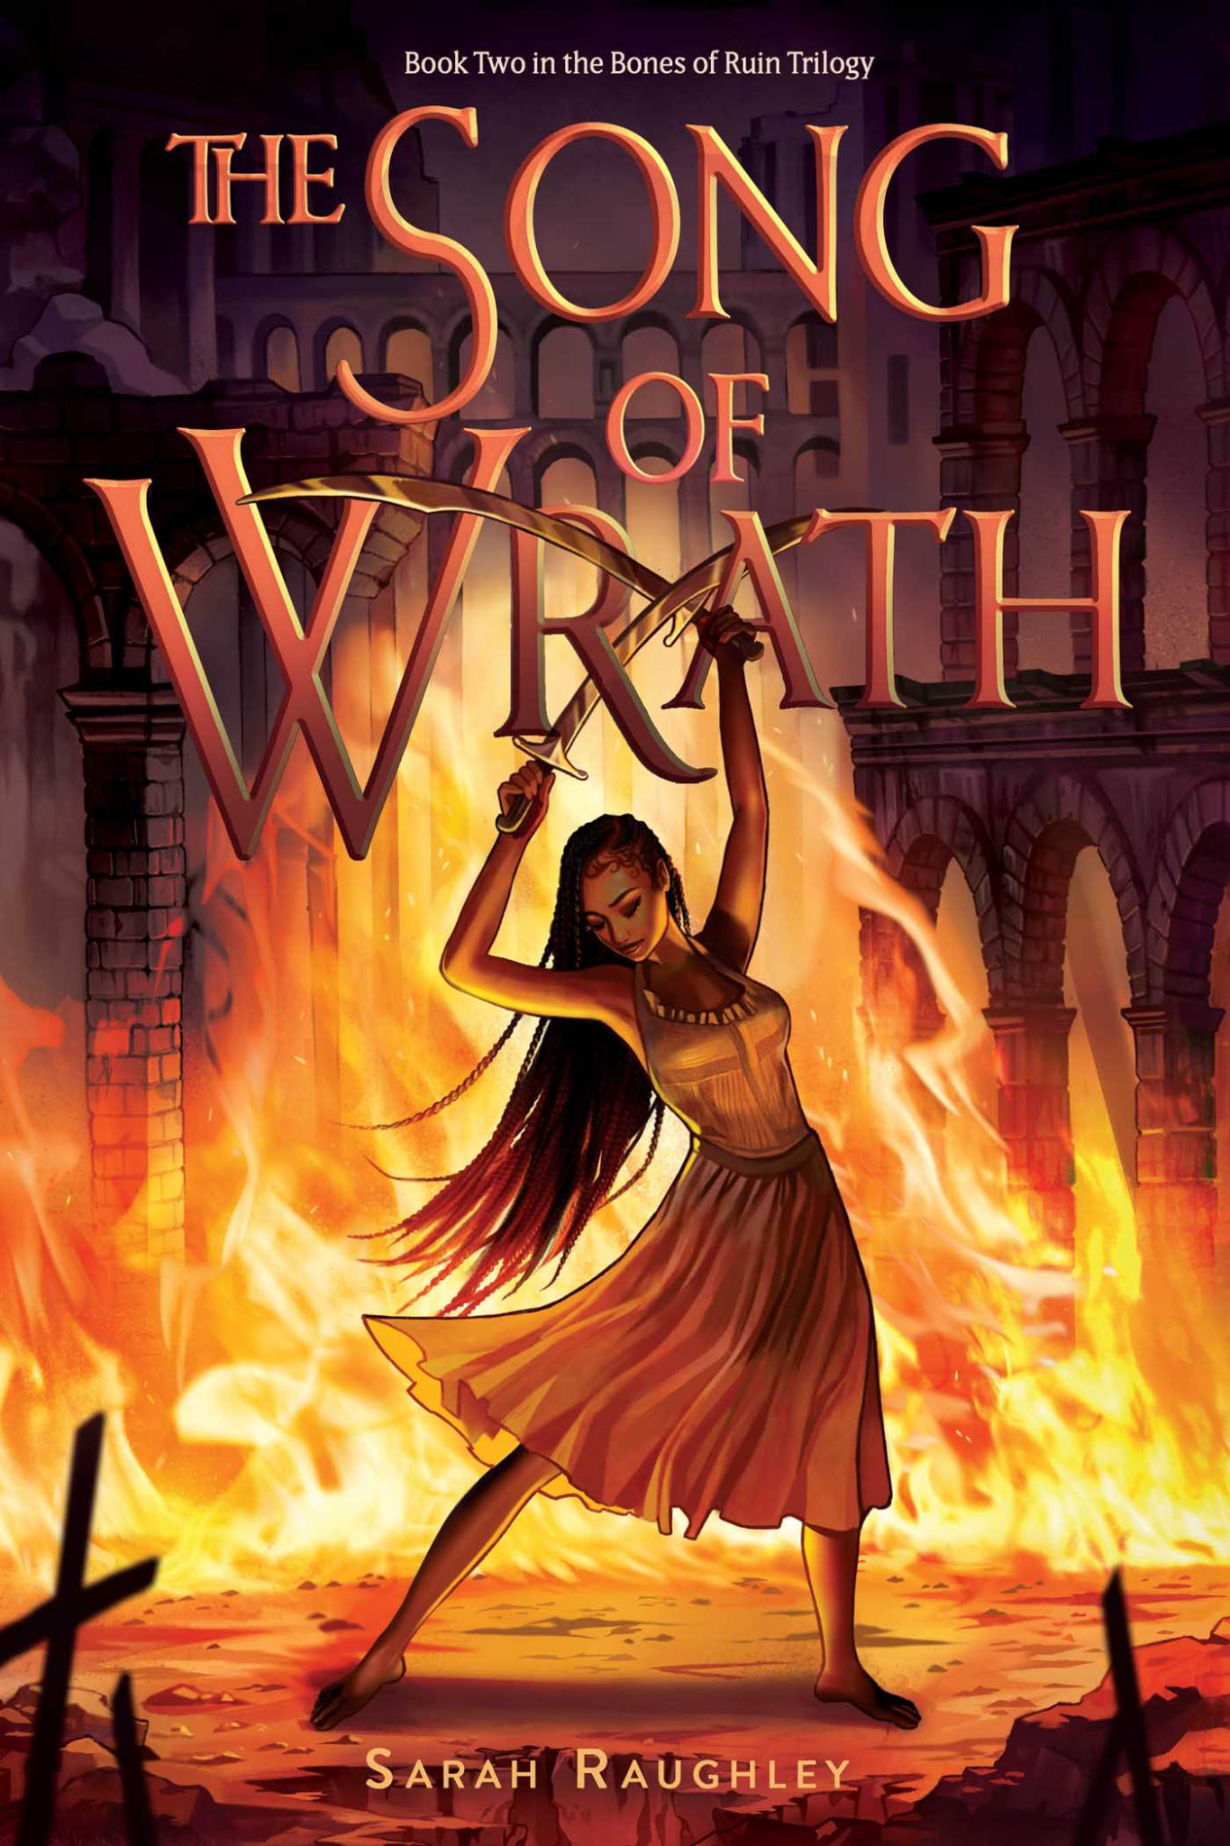
By Sarah Raughley
( https://d28hgpri8am2if.cloudfront.net/book_images/onix/cvr9781534453593/the-song-of-wrath-9781534453593_hr.jpg )

Author

Author Information: Sarah Raughley was born in Ontario, Canada.She currently has three series published with several standalone novels. Currently, she is working on a new series with the first book expected to be released in 2025. Raughley has a PhD in English. Her website is https://sarahraughley.com/.
Points of Interest
- Sarah Raughley has been writing fantasy stories with female protagonists since she was a child.
- Sarah Raughley gives credit to Jane Austen for having inspired her writing style.

Summary
Being the second book of the series begins with Iris displaying the resolve she was able to gain from finding out who she is. Hiva, an “ancient murderous god kept hidden behind the wall of “Iris.” Upon her allies discovering this, they themselves had a choice to make. This book brings up topics of race, religion, identity, and relationships in this fantastical young adult novel. The main character is an African woman who has to deal with constant pressures of becoming or not becoming something she has no control over. She gains and loses friends and loved ones, and she dies.
Significant Quotes
1 “Men like him had given her names before. Isoke: She Who Does Not Fall. Given by the king of Dahomey, who’d forced her to fight as one of his warriors fifty years ago” (16)
Iris, since being created, hasn’t truly been able to live her own life. Even while her memories are gone she still has to literally perform for others entertainment, with disregard for her safety. In this quote Iris reflects on how she had been used over her lifetime in a determined tone. This shows Iris’s resentment towards her lack of free will, while also showing her resolve.

2 “If I am a monster known for killing your father, then how much more so is the woman who will destroy the world and everything else you hold dear?” (133)
This specific line from the quote shows up three times throughout the book. While it is in rather quick succession it is one of the most important lines in the book as it foreshadows the main climax of the book. When it was first said Gram had warned Jinn that a monster “becomes.” This is vital as Jinn’s first steps to becoming a monster had already been taken before his full reveal when he kills Iris in the end.

3 “It had all happened here in this place. She looked around the glittering mine. The stone seemed to be singing to her quietly.” (270)
Once again her allies question her. Once again someone she loves shows their fear because of their lack of understanding. It isn’t as though they don’t trust her, but they can see that she doesn’t trust herself. Max’s name was yelled many times before Iris was stabbed from behind making me think that it might have in fact been Max who had done the final blow. This scene, I believe, is supposed to add to the climax’s suspense.
Education
In a real-life scenario I wouldn’t teach this book in class as I would teach elementary. The main reason I wouldn’t teach this in my classroom is that it is part of a series. However, if I were to teach 5th or 6th grade, I wouldn’t be opposed to a poster of the first book in the reading section of the class. I would also make this an optional book for spring or summer break reading. If I were to present the book, I would be presenting it with a slew of other fantasy books as optional reading devices. The recommended age level for Song of Wrath is 12 years old, however the first book of the series is recommended to be read by 14 year olds. Teens should read this book because it is a solid fantasy novel with a bunch of people of color as the main characters, adding racial perspective. The different cultures brought up in this fantastical world could bring more magic to their own.
Chapters in Adolescents in the Search for Meaning: Tapping the Powerful Resource of Story
Chapter 4: Books about Real-Life Experiences:
- Iris deals with betrayal.
- The plot is set in a world similar to real-life.
Chapter 5: Books about Facing Death and Loss:
- Jinn has to deal with his fathers death.
- The looming apocalypse is the main part of the story.
- While Iris can’t die, she still fully experiences death, each time it bears significance as she seems to lose a little bit of “Iris” each time she comes back.
Chapter 6: Books about Identity, Discrimination, and Struggles with Decisions:
- There are times where Iris has to deal with discrimination based on her skin tone.
- Iris’s inner monologues throughout the book are focused on her struggle with her own identity. While she has regained her memories, she still struggles with her sense of self.
- While Iris struggled with decisions, she did not struggle as much as her allies when it came to trusting her.
Chapter 7: Books about Courage and Survival:
- In the book the characters showed courage by fighting alongside Iris.
- With the looming apocalypse everyone wants to prevent it in order to live.
Chapter 8: Books on Allegory, Fantasy, Myth, and Parable:
- This is a fantasy novel with magic powers that the characters control.
- Hiva seems to be a nod at Shiva, known as The Destroyer in Hinduism

Text Complexity
Quantitative
Quantitatively speaking, this book is about average to slightly above average for young adult literature across the sources provided in the Text Complexity handout. Though it is slightly lengthier than some students would be used to, at 432 pages, it is meant for ages starting at 12 years old. What puts it slightly ahead is the sentence length, and the vocabulary choice. There were times when I had to look up some of the words as I had never seen them before.
Qualitative
-Structure
- First person perspective
- The plot is simply laid out, similar to many young adult novels, as the main events and dialogue are very often followed by a monologue of how the character had felt about the event.
-Language Conventions and Clarity
- The dialogue was straight-forward making it easy to follow.
- There weren’t many uses of slang, but difficult words sometimes are involved in the text.
-Knowledge Demands
- It demands you to know racial features as that is sometimes all that is given of a character's features.
- Another thing that it assumes you know is the social dilemmas of race, as when it is brought up, it is not informative, but rather a demonstration.
-Levels of Meaning
- Identity: She is dealing with the battle between her identities.
- Perspective: Since it is first person we can’t tell what others are plotting.
- Purpose: Finding one's purpose or acting because of one’s purpose is brought up in all the characters we get to peer into the minds of.

