Cynthia Bocanegra
Professor Warner
English 112B
28 October 2023

Woven In Moonlight
By Isabel Ibañez

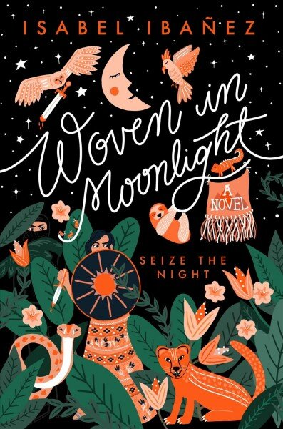

About the Author


Source: http://isabelibanez.com/
Picture:https://images.squarespace-cdn.com/content/v1/5730a62227d4bdb4d51cd41f/1574097081495-N9TVR7O8Z7B4T0JTR3GI/Isabel+New+Headshot.jpg?format=2500w

Isabel Ibañez was born and raised in Boca Raton, Florida by her Bolivian immigrant parents, she currently lives in Asheville, North Carolina. Aside from being an author she also is a graphic designer, specializing in greeting cards. Isabel Ibañez is best known for her book Woven in Moonlight as it was a finalist for the William C. Morris Award, and is listed in Time Magazine’s 100 Best Fantasy Books Of All Time. Connected with her Bolivian roots, Ibañez wrote Woven in Moonlight inspired from Bolivian politics and history, as the setting is inspired by a land in Bolivia called Inkasisa.

Summary
Woven In Moonlight surrounds a girl named Ximena, who is a decor of the Illustrians Condesa. The Illustrians lost everything when Atoc, the usurper, used an ancient relic called the Estrella, to summon ghosts and push out all the Illustrians out of their land, La Ciudad. Atoc demands the real Condesa’s hand in marriage, yet as the decoy Ximena goes instead to fulfill a mission. Ximena is on a mission to find the Estrella and return it back to the Ilustrians, yet her mission becomes complicated when she meets a masked vigilante called El Lobo, the warm-hearted princesa of the Llacsans, and a thoughtful healer. Ximena starts to think there is a better way to overthrow the usurper without starting another war, but it would mean she has to turn her back on the revenge she desires, and her loyalty to the real Condesa.

Quote #1
“The anger I carry for the Llacsans has been my closest friend ever since I spent time on the streets after my parents’ deaths. It’s fueled me. Motivated me to survive. Anger carried me to the castillo gates… My realization feels important somehow.” (168-169)
The significance of this quote is due to Ximena’s change of heart. Ximena starts to understand that not every Llacsan is a disheartened person, and it’s presented through the maid that helps her get ready for the day, and one of the guards that is stationed in front of her room. She starts to realize that she doesn’t have hatred towards all the Llacsans, she just has hatred for the corruption that is presented by the usurper Atoc and the Priest that is loyal to him. This shows character development as Ximena starts to understand the reality of the Inkasisa people.

Quote #2
“Princesa Tamaya taps her index finger against her chin. “I’d bet all my good health you don’t know what the Estrella actually is.”... But what’s worse, I never thought to ask about the gem’s origins.” (204)
This quote is significant as it shows Ximena learning the truth of her people and the history between the Illustrians and the Llacsans. She learns that when the Illustrains were in power they were just as bad as the Llacsans, using the Estrella, which holds the lives of the miners who were forced to retrieve it, and abused their power over the people because of their greed, once they had it. This is the point where Ximena starts to question what she should do versus what she must do. To follow the plan of her Condesa and have the Illustrians take control again or rethink new ways to have peace in Inkasisa.
Quote #3
“Sobs wreck her body. I reach for her, but she shoves me away… But she needs to know how I feel. Me, her friend. Not a decoy. “I do.” (288-290)
The significance of this quote is due to Ximena finally stepping into her own and confronting the real Condesa Catalina. Ximena argues that she knows better now and sees a new way of overthrowing the corrupted king and having peace in Inkasisa. This comes with backlash as Catalina feels she’s been brainwashed and turned against her. This also shows character development as Ximena has come out of her shell of only being the Condesa decoy. She finally is being her true self and standing for what she believes is the right thing to do.

Classroom Use

I would present Woven in Moonlight with a powerpoint lecture on the themes of identity, power and abuse, feminism, fate and free will, and leadership, then discuss the relatability of these themes within the real world, as these are crucial aspects that are presented within the novel. I would have the students participate in a class activity where they would find examples of social deviance within the novel and have a class discussion of how Ximena defined what she should do vs what she must do or how Ximena is a strong female character. Another activity that I would do is a class discussion on what makes a good leader, as the theme of leadership is prominent within the novel. I believe a good age for students to read Woven in Moonlight is about 14-17, due to the themes that are presented within the novel as they would help with the critical thinking skills and communication skills of the students.

Chapter 5 of Adolescents in the Search for Meaning: Tapping the Powerful Resource of Story
- Because Ximena had lost her parents at a young age which makes her angry and drives her pursuit for revenge. This can be relatable to teens who have lost someone close to them, and may feel the same emotions that Ximena feels, to be angry at the world and want something or someone to blame.

Chapter 6 of Adolescents in the Search for Meaning: Tapping the Powerful Resource of Story
- Because Ximena struggles with being true to herself as Ximena and not being like Catalina, and playing the part of the Condesa decoy. Teens can relate as they may feel they need to be someone else to fit in and be accepted.
- Ximena struggles with the decision of staying loyal to her mission or doing what is right and turning her back on her revenge and the condesa. Teens can relate as they might struggle with peer pressure and be in a situation of choosing to do the right thing or to do what is wanted by their peers.

Chapter 7 of Adolescents in the Search for Meaning: Tapping the Powerful Resource of Story
- Ximena presents social deviance as she goes against her own people, and tells Catalina that she should not be Queen, this shows courage. Teens may relate to this as they may have to set boundaries with their peers, and speak their truths to others.
- Ximena being the Condesa decoy for her people shows courage as she is placing herself in dangerous enemy territory. Gives a better perspective of what courage looks like for teens, as it is hard to understand the perspective of some courageous people, for example not every teen is not going to know what it’s like to protest against their government, or fight for their country or land.

Chapter 8 of Adolescents in the Search of Meaning: Tapping the Powerful Resource of Story
- Ximena uses magical moondust to make the guards fall asleep, and weaves animals with wool that has moondust on it which makes the animals she weaves come to life. This gives teens the chance to be in a different world than their own, a world with magical moondust that makes people fall asleep, and tapestry animals that come to life.
- Ximena prays and puts her trust and faith in the moon goddess known as Madre de Luna. This gives teens (including myself) who are fascinated with the moon a chance to see the moon as a person/goddess.

Quantitative
Dale-Chall: Grade Level: 5-6th Grade
ATOS: ATOS Level: 5.59
Flesch-Kincaid: 7th Grade

Qualitative
- Structure
- First Person POV
- Linear Plot
- Language Conventions and Clarity
- Word choice and vocabulary are simple.
i. There are bits of Spanish words since the setting is in Bolivia, this creates a cultural environment as the characters speak Spanish.
- Imagery is used within the novel as Ximena is in a castillo and is among royalty.
- Levels of Meaning
- The novel mentions power and abuse, as well as greed and corruption.
i. King Atoc uses koka leaves as a product of consumerism to become more wealthy, at the cost of the country's vegetation and the people of Inkasisa’s homes.
ii. The Estrella (ancient relic), is used as a weapon between the Illustrians and the Llacsans.
- Knowledge demands
- There aren't as many knowledge demands as the history between the Illustrians and the Llacsans.
i. Ximena and Princesa Tamaya have a discussion and present the information of the history between the Illustrians and the Llacsans and why their people have conflict with each other.

