Presley Lugo
T 4:30 ENGL112B
Dr. Warner
Book Talk
10.22.19
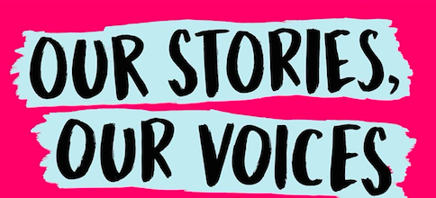
✶Summary✶

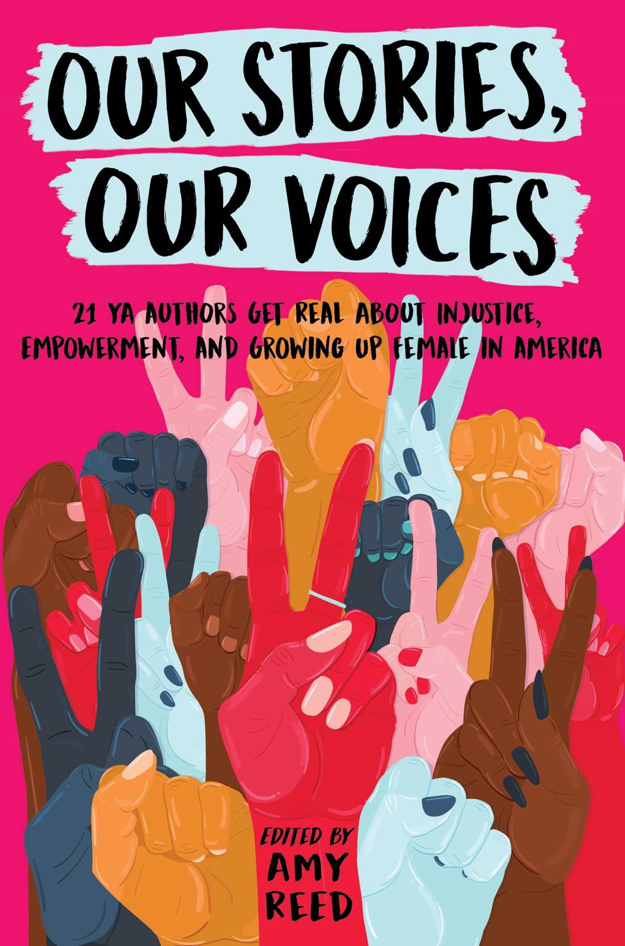
Our Stories, Our Voices is an anthology of biographical short stories from 21, young adult, female authors. The stories that have been gathered discuss the authors’ personal struggles with sexual assault, abuse, racism, fat phobia, gender identity, feminism, and activism. Majority of the short stories bring up or are centralized around the 2016 presidential election. They discuss how the rise in racism, rape culture, and hate crimes after the 2016 election have affected them and have triggered PTSD from past experiences. This book’s overall theme, however, is a message of hope and empowerment for women. These 21, young adult, female writers have gained a voice through their writing, and each show that in their short stories, their words and voices matter.

✶ About the Authors ✶

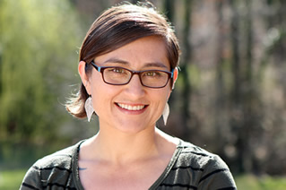
✶ Amy Reed is the editor of Our Stories, Our Voices. In the collection she wrote the introduction and “Finding My Feminism”. In her short biographical story she discusses her struggle with identifying her self as a rape victim. Reed discusses the stigma of rape and has a hard time determining if she has been raped enough to be considered a victim of rape. Reed also, struggled with her feminist identity. Reed also write about her guilt for identifying herself as a feminist because she’s used feminism as an outlet to hate herself.
Reed was born and raised in Seattle, where she was constantly moving around the area and attended a total of eight schools. She moved to San Francisco and graduated from New College California with an MFA. She lived in San Francisco for 13 years until she moved back to South Carolina.
Amy is the author of Beautiful (2009), Clean (2011), Crazy (2012), Over You (2013), and Damaged (2014), Her two-book series, Invincible (2015) and Unforgivable (2016), The Nowhere Girls (2017), and The Boy and The Girl Who Broke The World.
Pictures and Information was found at Amy Reeds Website: https://www.amyreedfiction.com/bio/

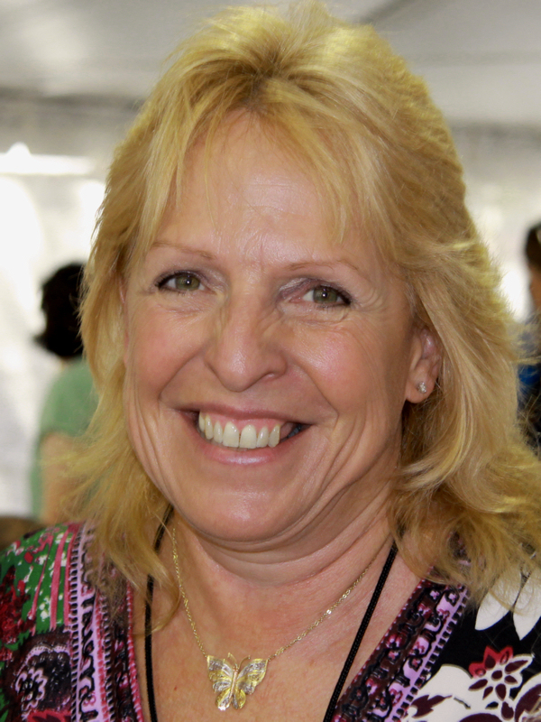
✶ Ellen Hopkins in the anthology, wrote “An Accidental Activist.” In her short story, Hopkins opens up about growing up unaware of her white privilege. After writing a report on Robert Kennedy when she was younger, she recalls being inspired by his willingness to help others. Also driven by the desire to be more than her dependent mother, who seemed to lose herself after her father’s death, Hopkins consumes herself with activism. She addresses the importance of standing up for what you believe in and the importance of voting.
Hopkins grew up in Palm Springs, California near celebrity’s homes, Elvis Presley being one them. Hopkins was an avid reader and writer for as long as she could remember, but didn’t start making money off her writing until 1992. Hopkins graduated from Santa Ynes Union High School in 1973 and studied journalism at Crafton Hills College and University of Santa Barbara, but dropped out to marry and start a family. Hopkins currently lives in northern Nevada with her current husband John Hopkins.
Hopkins is the author of 14 young adult literature books including Burned (2006), Crank (2004), Impulse (2007), Identical (2008), and Glass (2007). Hopkins has also written four adult books including A Sin Such As This, Loves Lies Beneath, Collateral, and Triangles.
Pictures and Information was found at Ellen Hopkins’s Website: http://ellenhopkins.com/about.html
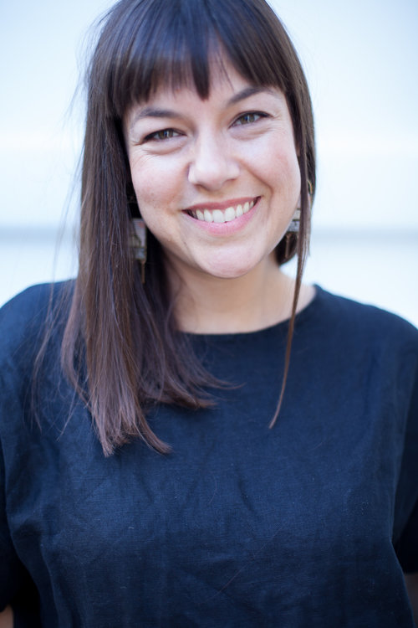
✶ Nina LaCour wrote “Changing Constellations” in Our Stories, Our Voices. LaCour writes about how she felt guilty as she watched her friend be bullied for being openly gay in High School. LaCour didn’t come out until she was older, and she recollects how she felt guilty that she came out at a more convenient and accepting time. She dedicated her short bio to her friend from High School.
LaCour graduated from San Francisco State University and received an MFA in Creative Writing at Mills College in Oakland. LaCour has devoted her life to teaching, tutoring in college and then teaching undergraduates while attending grad school. She has also taught at Berkeley City College and Maybeck High School.
LaCour's books include, Hold Still, The Disenchantments, Everything Leads To You, and You Know Me Well.
Pictures and information was found at Nina Lacour’s Website: https://www.ninalacour.com/aboutnina

✶Complexity✶

✶Qualitative:
For the text complexity, because there are multiple authors with varying degrees in writing styles and complexities, I had decided to test the text complexity for multiple authors. The Lexile Range gave a grade-band equivalent score ranging from 2nd to 12th grade. I agree with having 11th to 12th grade readers read this anthology because of the sensitive content. Because some of the works in the collection use safe and less complex words and phrases, I understand why the Lexile Range tool would recommend this book to 2nd graders. New Dale-Chall Readability Index gave the same grade-band equivalent for all three works used. I do believe that some of the content in the anthology would be suitable for 7th and 8th grade students; however, some content in the book would need to be excluded as it is more sensitive.

Lexile Range: “Finding My Feminism” (Reed, 19)
410L - 600L GRADE 2

Lexile Range: “An Accidental Activist” (Hopkins, 191)
810L - 1000L GRADE 5-7

Lexile Range: “Changing Constellations” (LaCour, 158)
1210L - 1400L GRADE 11-12

New Dale-Chall Readability Index: “Finding My Feminism” (Reed, 19)
Grade level: Grades 7 – 8

New Dale-Chall Readability Index: “An Accidental Activist” (Hopkins, 191)
Grade level: Grades 7 - 8

New Dale-Chall Readability Index: “Changing Constellations” (LaCour, 158)
Grade level: Grades 7 - 8

★ ✶Quantitative: This books deals heavily with real life situations that would not normally be found in a lot of literature. Because all of these stories in the anthology are true, it makes it more difficult to read, especially stories about rape and hate crimes. Because of this, the Exeter Study qualities that would fit with this collection of works would be 3, 5, 7, and 8. The book presents the authors’ experiences that are relevant and relatable to teen readers, especially to female teen readers. The anthology also varies in language because of the different authors’ voices that are present, allowing readers to deepen their reading comprehension as they change and adjust to the different tones, voices, and dialogues in each story. The complex and emotional story presented in the anthology also allow for personal growth and development as readers will relate certain stories back to their personal issues.

✶Quotes
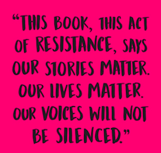
✶“‘All girls are as distinct as individual stars in the sky. All girls are also part of the universe’s infinite pattern. How wonderful, to be just like all the other girls in this way. How wonderful to be part of this vast and dazzling existence.
The dust of the baseball field is made from the dust of stars. And so are you and I, and this is the truth: watch all of us emerged from the soft hollows of a single woman who was like no other and yet like all the others. We are all linked backward through time to the first star that pierced the velvet of night.
Billions of us, and every last one of us full of light so brilliant it stings, if only we are brave enough to look’” (Brokenbrough, 237).

Analysis of Quote
This quote is taken from the autobiography, “Not Like The Other Girls.” In Martha Brokenbrough’s story she questions what it means to be a “good girl” and how she has to live up to the “good girl” expectation. Because Brokenbrough was sexually assaulted and raped, she felt that she could no longer identify as a good girl. This quote plays an ironic role in the theme of the short story. Brokenbrough is stating that, although girls are unique and different, we all share a common trait and that is that all girls are a part of the universe’s pattern.

✶ “‘And there were people who worshipped and fed off that hate, lots of people. They rejoiced at the way hate spoke, at the assumptions it made, at the way it lashed out with astounding regularity. This hate wore a suit. It came under the guise of success. And the people around him dressed up in their hate too. They wore shirts and hats promoting it. They aligned themselves with it and started vocalizing their own hate. They felt empowered. I saw them standing there, behind their leader, on television. I spent a lot of time just looking at their faces. They looked like teachers. They looked like people who checked out my groceries. Except here, their faces were all twisted up. They were beaming with hate. No, they did not wear hooded cloaks. They made hate look professional and polished and astoundingly normal’” (Sanchez, 246).

Analysis of Quote
This quote was taken from, “Is Something Bothering You,” and in this short story Jenny Sanchez, writes about the fear her family had endured when her father was threatened during his job, because of his ethnicity. Sanchez discusses how the current president’s hate has encouraged others to act out on their own hate. The idea that Sanchez raises is that, most people who are racist are people who seemed normal. They were people, Sanchez explains, that were a part of her everyday life. The idea that the people who were empowered by the hate of President Trump, seemed as if they were people who would normally show respect are now able to express their true identity and their “twisted” faces of hate.

✶ “‘In the weeks that followed, nearly two dozen women from all walks of like came out of the shadows to tell the world that they had been sexually assaulted by Donald Trump—accusations that spanned decades. His response was to call them all liars, threaten to sue them, even claim they were not attractive enough for him to want [to assault]—anything to avoid admitting any wrongdoing on his part. This is nothing new, as we’re seen in recent years, but the elevation and legitimization of the shaming and discrediting tactics that are used to keep survivors silent was brought to new proportions in this election. Politics aside, the simple fact that all of this was overlooked, forgiven (though never apologized for), and that he was still able to become president is the epitome of rape culture.
… For many of us who felt as though the violence perpetrated against us didn’t matter, or that we couldn’t find any support, or that no one understood or even cared, it was like watching versions of our own traumas and our worst nightmares being played out on the world stage. These are all the experiences that, for many, cause damage that can take a lifetime to heal, yet in one moment all those old wounds were reopened when this admitted sexual predator was handed one of the most powerful positions in the world’” (Smith, 266).

Analysis of Quote
This quote comes from the story “What I’ve Learned About Silence” by Amber Smith. This quote is significant because, similar to the previous quote, this quote addresses how the 2016 presidential election has brought forward past trauma for many women. Smith brings forward an important issue about women who try to accuse their assailant. The issue that many women who come foreword about their sexual assault are normally criticized or not believed and this quote shows how the most powerful man in the United States is following the same pattern. Although women are continuously being silenced, Smith argues that women will continue to speak up, like Smith has in her short story.

✶Rationale: Why Should Teens Read This?

1✶ Because this anthology deals with real life issues that some students might have experienced, but aren’t ready to talk about yet. This story provides an outlet for students to feel that they are understood.

2✶ Because this book is great way for students to practice reading with varying perspectives.

3✶ Because students should know the importance of feeling empowered through writing and using their own voice and experiences to stand up against important issues.

✶Methods for Teaching Our Stories Our Voices in the Classroom
1✶ The many themes in the book could allow for pairings with other novels. Certain stories could be used, instead of the entire anthology to be taught in conjunction with other novels that share similar themes, such as Speak, Kindred, The Awakening, and Thirteen Reasons Why.

2✶ Students could write their own empowering short biography. Using past experiences, students could write how those experiences have influenced choices or actions they have made and how those experiences shaped their identity.

3✶ Many young students might have trouble recollecting how the 2016 presidential election has effected them, students could practice creative writing and write stories creating characters and using different perspectives and write how the election effected their characters.

✶Chapters that this relates to in AifYAL:

✶Chapter 4: Books about Real-Life Experiences
This book deals with real-life experiences dealing with rape, discrimination, and body shaming. Authors’ use their own experiences to address current issues.

✶Chapter 6: Books about Identity, Discrimination, and Struggles with Decisions
The authors’ in this book are continuously faced with discrimination and put in situations where they must make decisions that will determines their overall identities.

✶Chapter 7: Books About Courage and Survival
Because many women in the anthology write about their survival from being a rape victim, they show courage. Also, many of the women who write about how they are activists or stand up against hate crimes show that these women are courageous. Finally, the sole fact that these women chose to write about their real-life experiences is also very courageous,

