Nicole Terry
Dr. Warner
Eng. 112B
October 21, 2024
Book Talk
The Giver
By
Lois Lowry
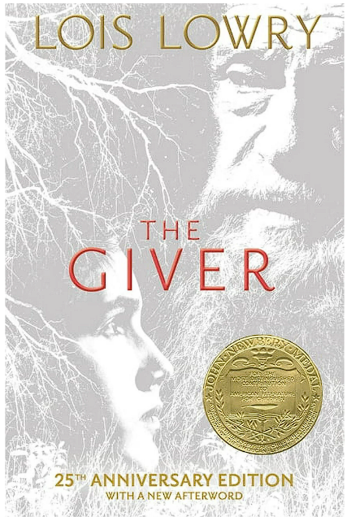
- Lois Lowry – Lois Lowry is an American writer. As an author, Lowry is known for writing about difficult subject matter within works geared towards children. She has explored such complex issues as racism, terminal illness, murder, and the Holocaust, among other challenging topics.

- Lois Lowry was a child of a military man. Her father was stationed all over the world, which allowed her to experience various locations such as Hawaii, Tokyo and New York. Lowry also married the military and continued to travel with her husband and now 4 children. The theme for most of her books are written around “human connections.” Lowry’s book The Giver is the first book of a quartet, Gathering Blue, Messenger, and Son are the remaining books in the series. These books stick with Lowery’s main theme, “The vital need of people to be aware of their interdependence, not only with each other, but with the world and its environment.” Married to her third husband, she continues to write and incorporate “awareness that we live intertwined on this planet and that our future depends upon our caring more, and doing more, for one another.”
- The Giver is a one-of-a-kind experience about a dystopian world where perfection and orderly are a must, and feelings are not recognized. In this world everything is in perfect order, babies are a number until they are named and handed over to suspecting parent, spouses are selected by whom is most compatible, children are applied for based off availability, and careers are chosen for you as a part of “The ceremony of the Twelves.” The main character Jonas is selected for one of the most necessary jobs within the community. He was selected as a “Receiver,” considered the most prestigious job in the district. Jonas’ role was to experience and accept all the pain, emotions and love from the city and hold it within himself; Jonas was to keep these emotions so no one else could experience pain, hurt or sorrow. When he witnessed a sorrowful event by his father, he realized there was more to the monotonous life he lived.
- • “The man sighed. “I started you with memories of pleasure. My previous failure gave me the wisdom to do that.” … “Call me The Giver,” he told Jonas” (109-110).
• “Not fair?” The giver looked at Jonas curiously. “Explain what you mean.” … “But when the conversation turned to other things, Jonas was left, still, with a feeling of frustration that he didn’t understand” (123-124).
• “His father turned and opened the cupboard. He took out a syringe and a small bottle.” … “Bye- bye, little guy,” Jonas heard his father say before he left the room. Then the screen went blank” (186-188).
- I would use this book in a classroom setting, I would say 7th grade would be perfect. I would create an inviting environment allowing all to share their thoughts on the book. Also, I can create questions around what worked and what didn’t work within The Giver. As a project, I would have kids create their own dystopian world, have them establish rules and guidelines for their cities. I believe teens should read this compelling story about making thoughtful choices and assessing whether they align with a better future. Chapter 6 from Adolescents in the Search for Meaning, does adequately reflect The Giver. Jonas, a young protagonist, is on an exploration for identity and often struggles with what is true and what is artificial. The Giver can also be associated with Chapter seven from Adolescents in the Search for Meaning. Jonas made a courageous choice, and soon he was faced with another obstacle, survival for him and a young infant. Lastly, the book can also be tied to chapter 8 from “Adolescents in the Search for Meaning.” The world surrounding Jonas is only a dystopian society. There are several other elements from “Adolescents in the Search for Meaning,” that were not noted; however, the key categories were included.
- Lexile Score: 760
Reading Difficulty: Average- slightly Difficult
Grade Level: 7-8
Age Range: 12-13 years
I believe The Giver can be understood by the average seventh grader. The book meticulously creates images from several scenarios as well as various locations. One of the many Exeter qualities represented in this book is “Imaginative and well- structured plots.” Each depiction and setting can be envisioned and connected to a part of the story. The story is an easy read from beginning to end. There is a clear flow that can be comprehended from any young adult. The story also has a strategy to keep one guessing on what could happen next, this aspect displays an additional Exter Quality; “Exciting Plots.” One of the strongest Exeter qualities is “Themes that allow the possibility of emotional and intellectual growth. Jonas is faced with a realization that his life has been constructed and he must decide on his future. I would highly recommend it as an easy read for junior high. I would anticipate that young readers are willing to read the story and continue onto the next. I am sure many teens can relate to the story and have parents who determine their futures and make choices for them. This story is simple enough for a young adult to be able to understand, “Key Ideas and Details.” Lowry does an immaculate job detailing the story and factors of each chapter. Young readers will also be able to initiate, “Integration of Knowledge and Ideas,” from the story. Lastly, many can comprehend the complexity of the story. The implicitly of the story is clear as Joan’s ask many bold questions about life. Many questions and concerns that are addressed by Lowry also cross over into today’s youth and create a real connectedness.

